250 Review

* Asymptotic notation

Big O: tight upper bound

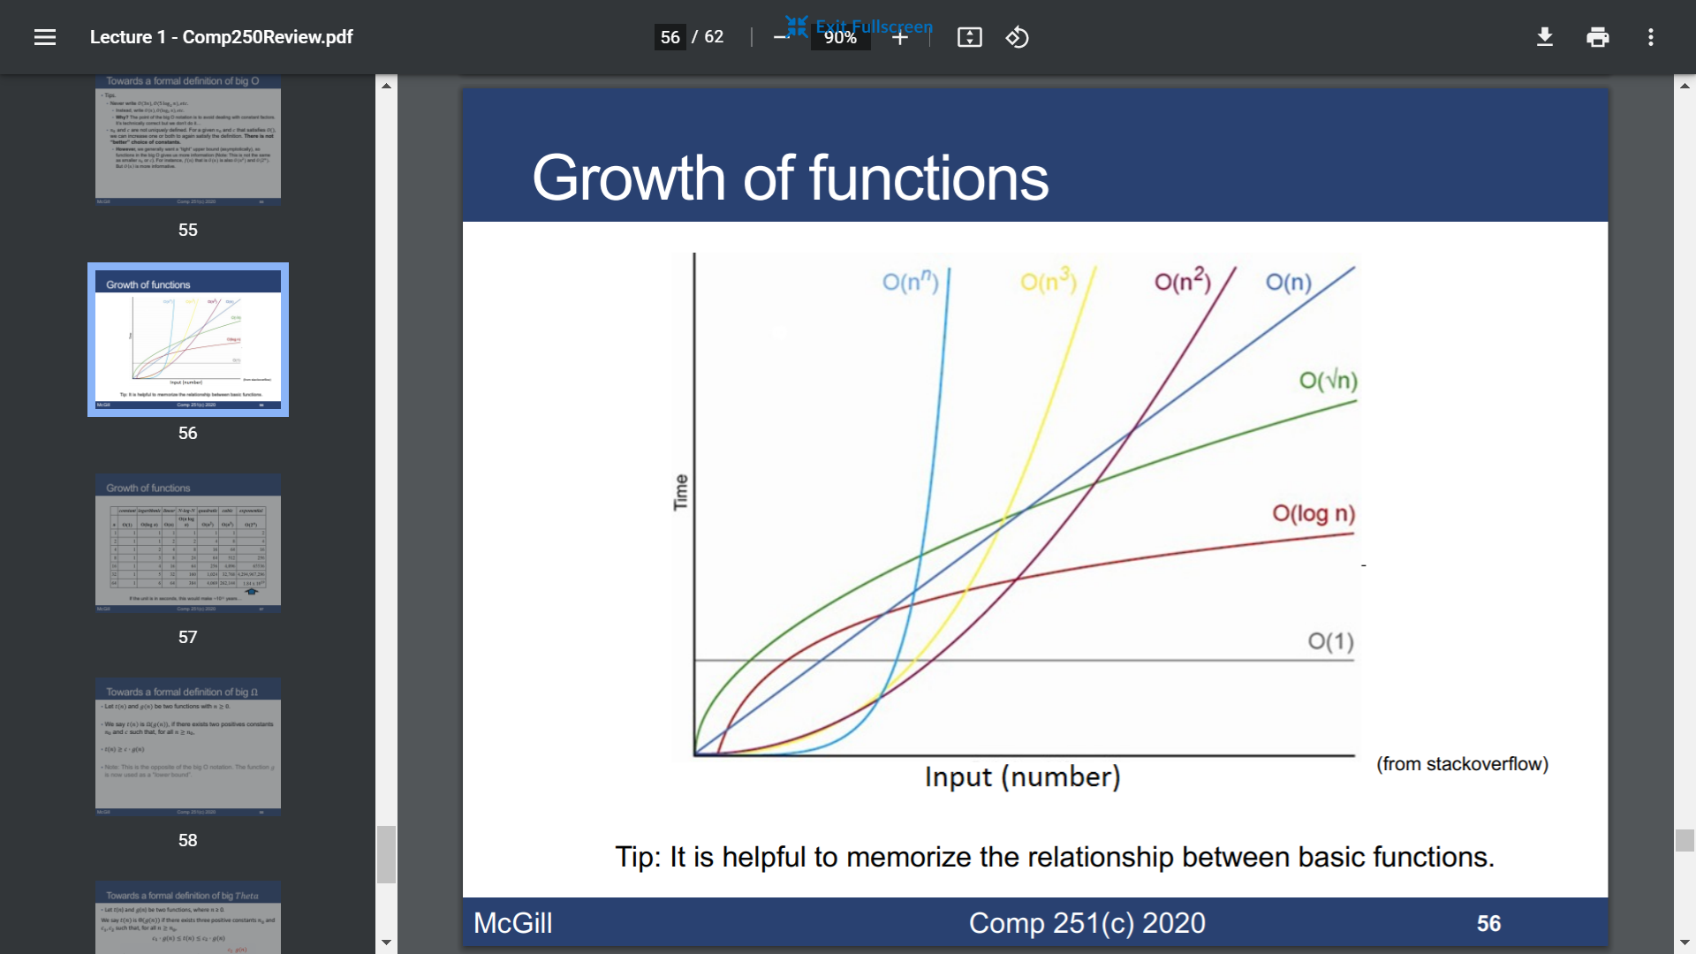

Big Ω: tight lower bound

Big theta: c1 g(n) <= t(n) <= c2 g(n)

Hashing

* Hash functions

Division method: h(k) = k mod d

Multiplication method: h(k) = floor [m (k\*s mod 1)]

Universal hashing: a finite collection of functions

* Collision-chaining

Insertion: O(1)

Deletion: search time + O(1) if use double linked list

Search: average O(1+a)

load factor a = n(#keys)/m(#slots) which is average length of list

* Collision-open addressing

Probe the table, insert if the slot is empty.

Deletion is difficult.

The expected number of probes in an unsuccessful search is at most $\frac{1}{1-α}$, in a successful search is at most $\frac{1}{α}∙log⁡(\frac{1}{1-α})$

Disjoint sets

* Disjoint set ADT

find(i) returns the representative

sameset(i, j) returns find(i) == find(j)

union(i, j) merges the sets containing i and j

* Union-tree representation

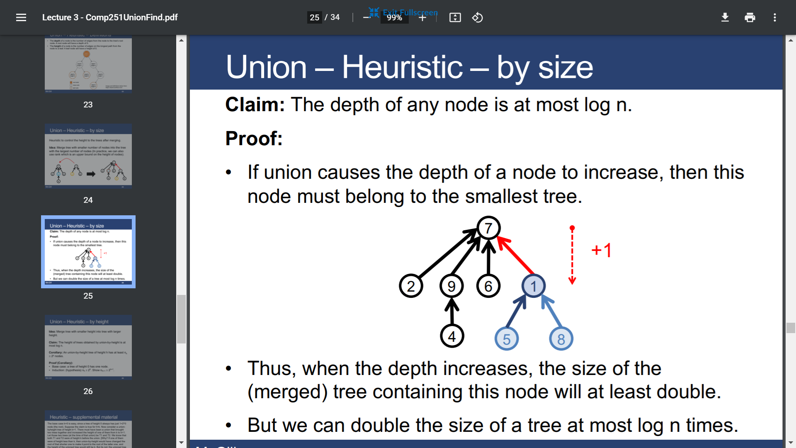

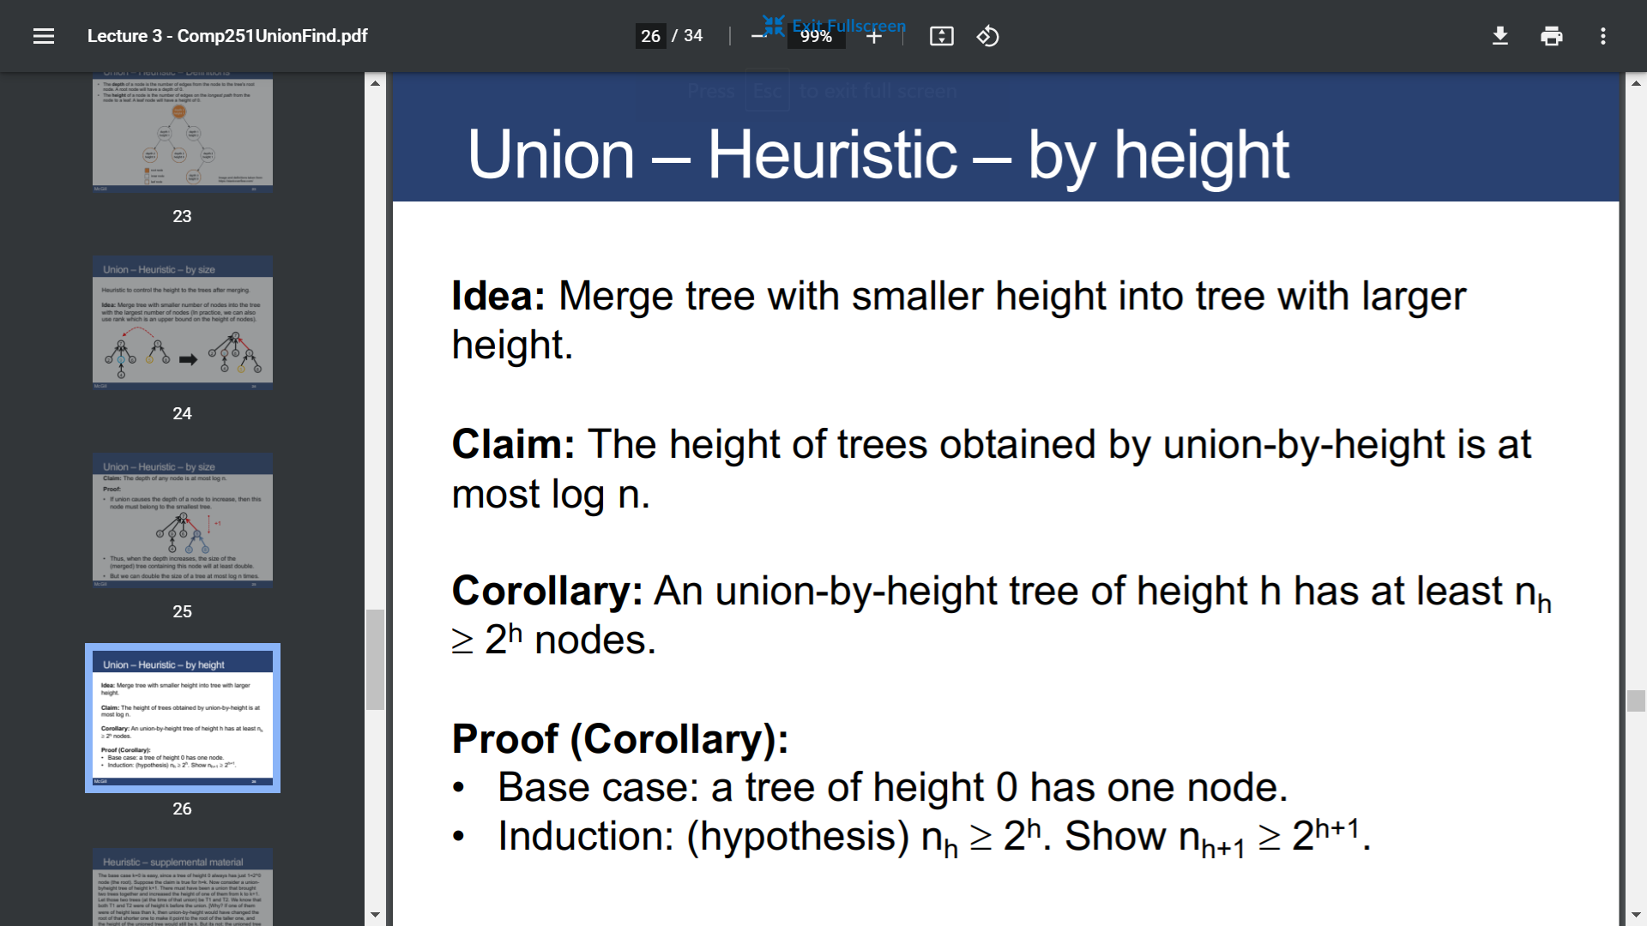

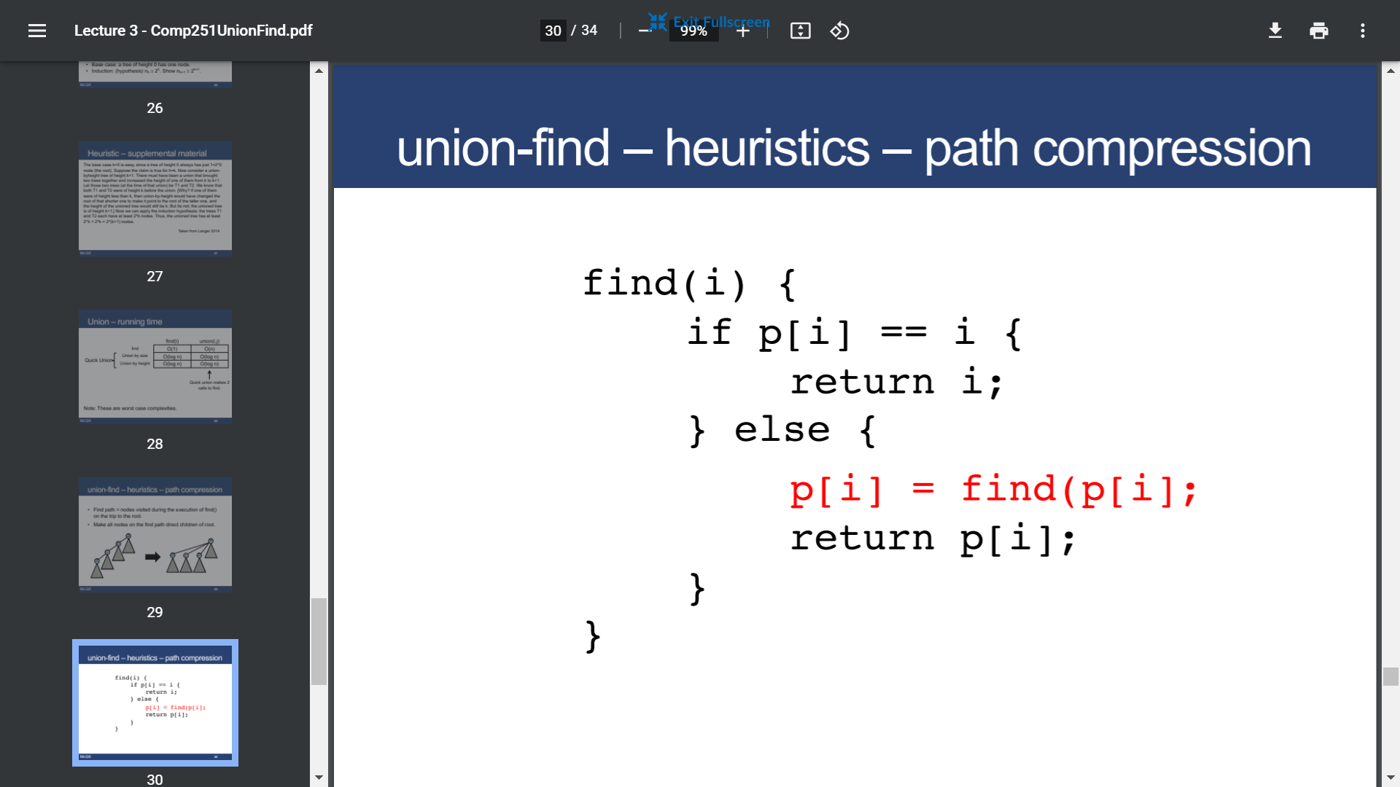

Heap

* Build a max heap

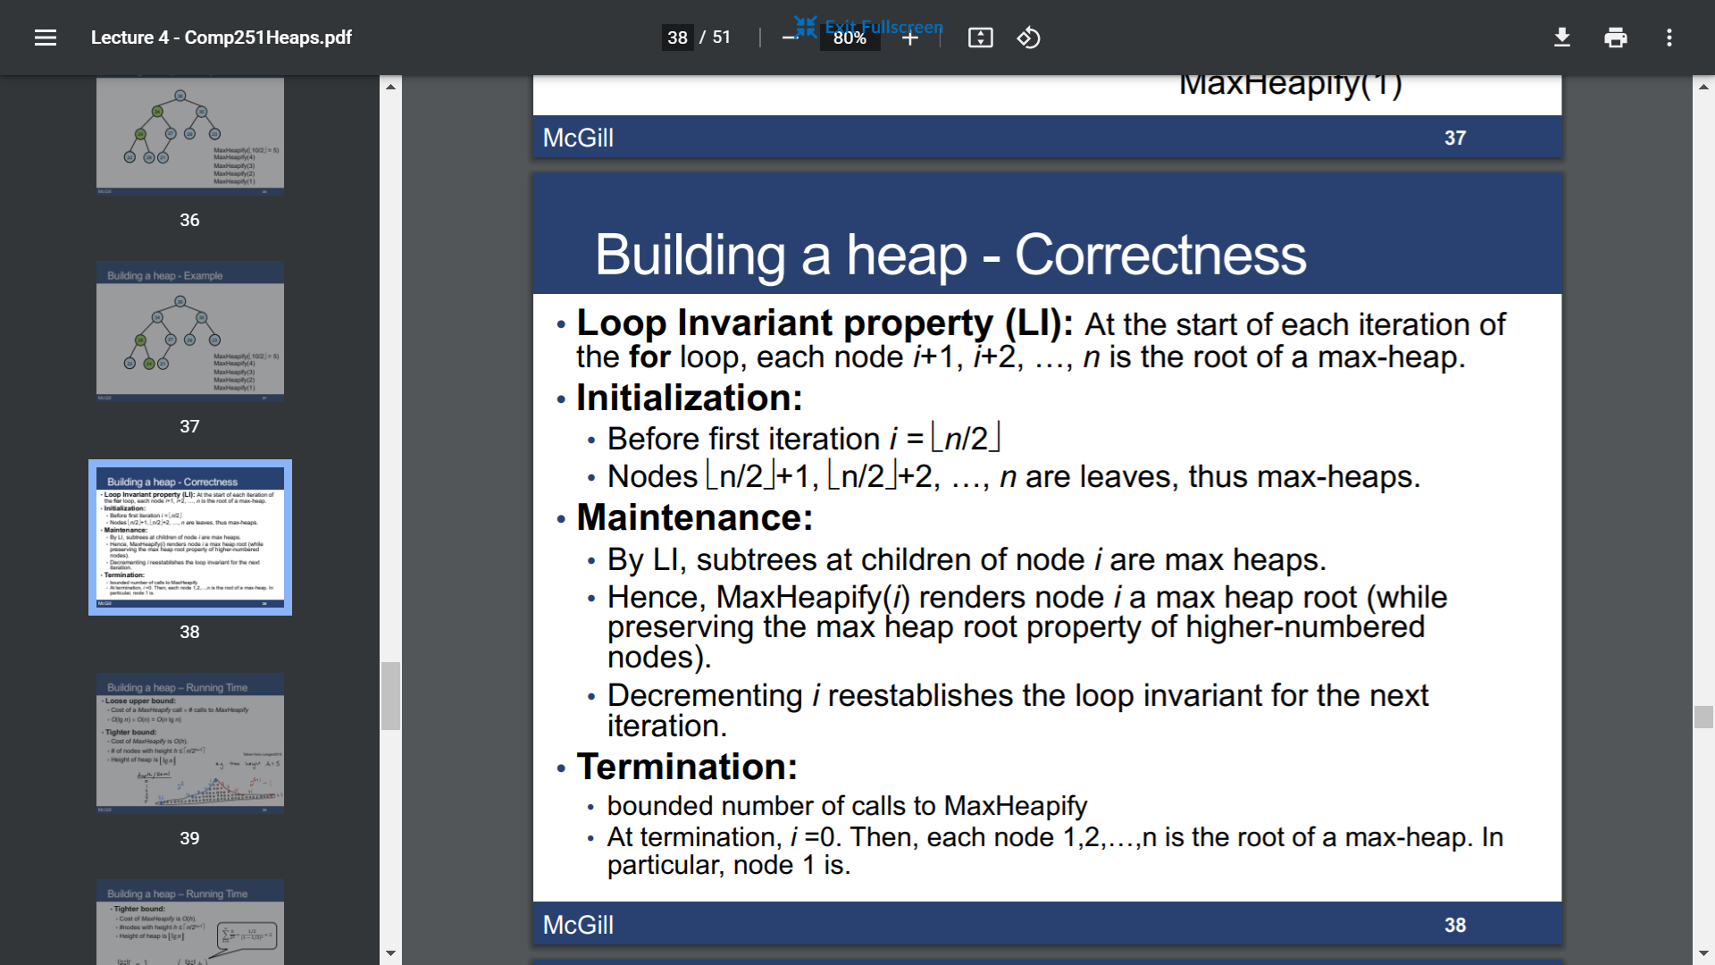

Running time: O(n)

* Heapsort

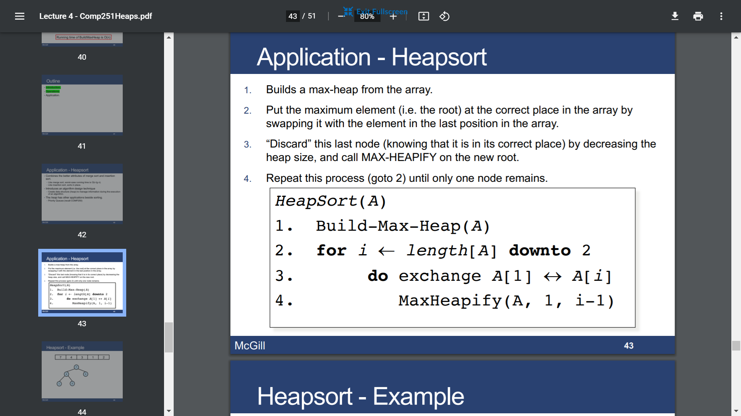

Running time: O(n lgn)

AVL

* AVL tree

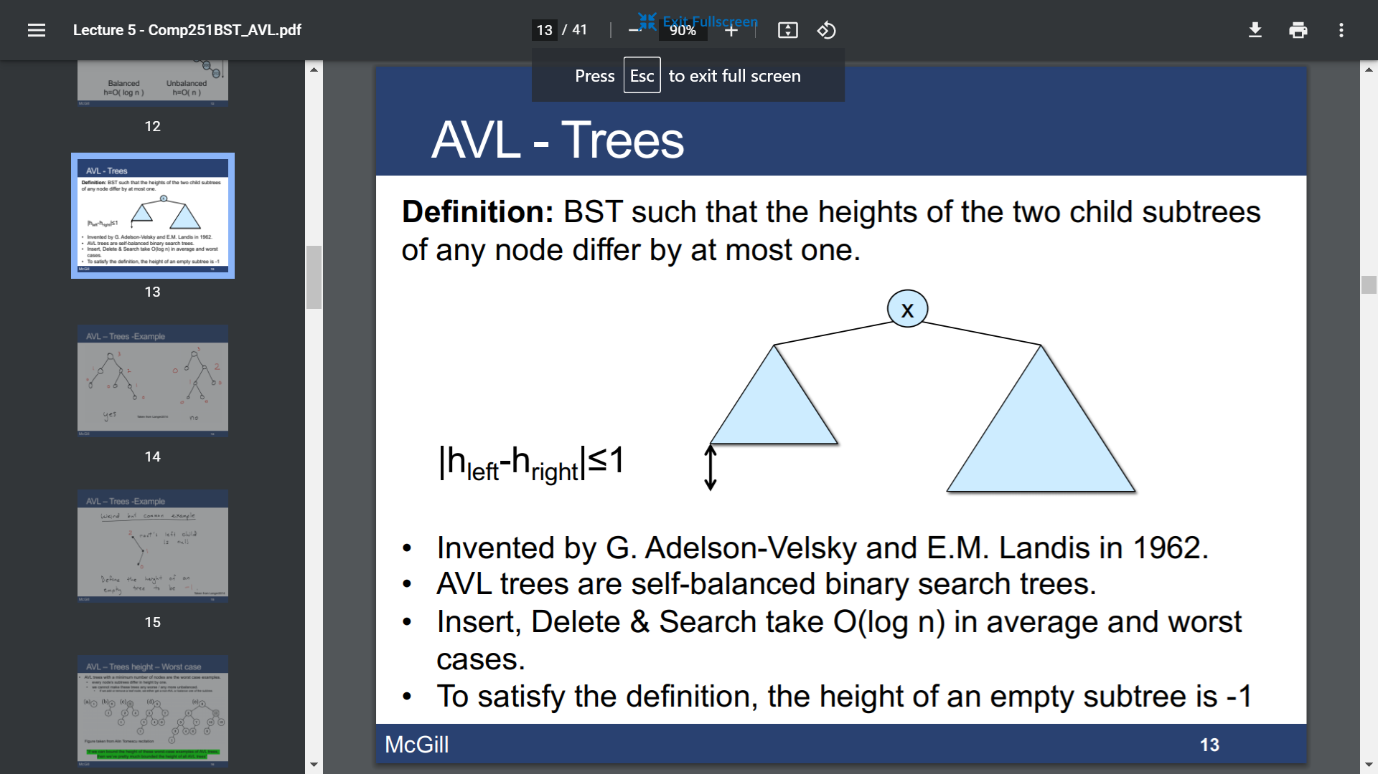

Balance factor: hL-hR (-1,0,1)

Rotation: right / left

Rotation change the tree structure and preserve the BST property

* AVL insertion

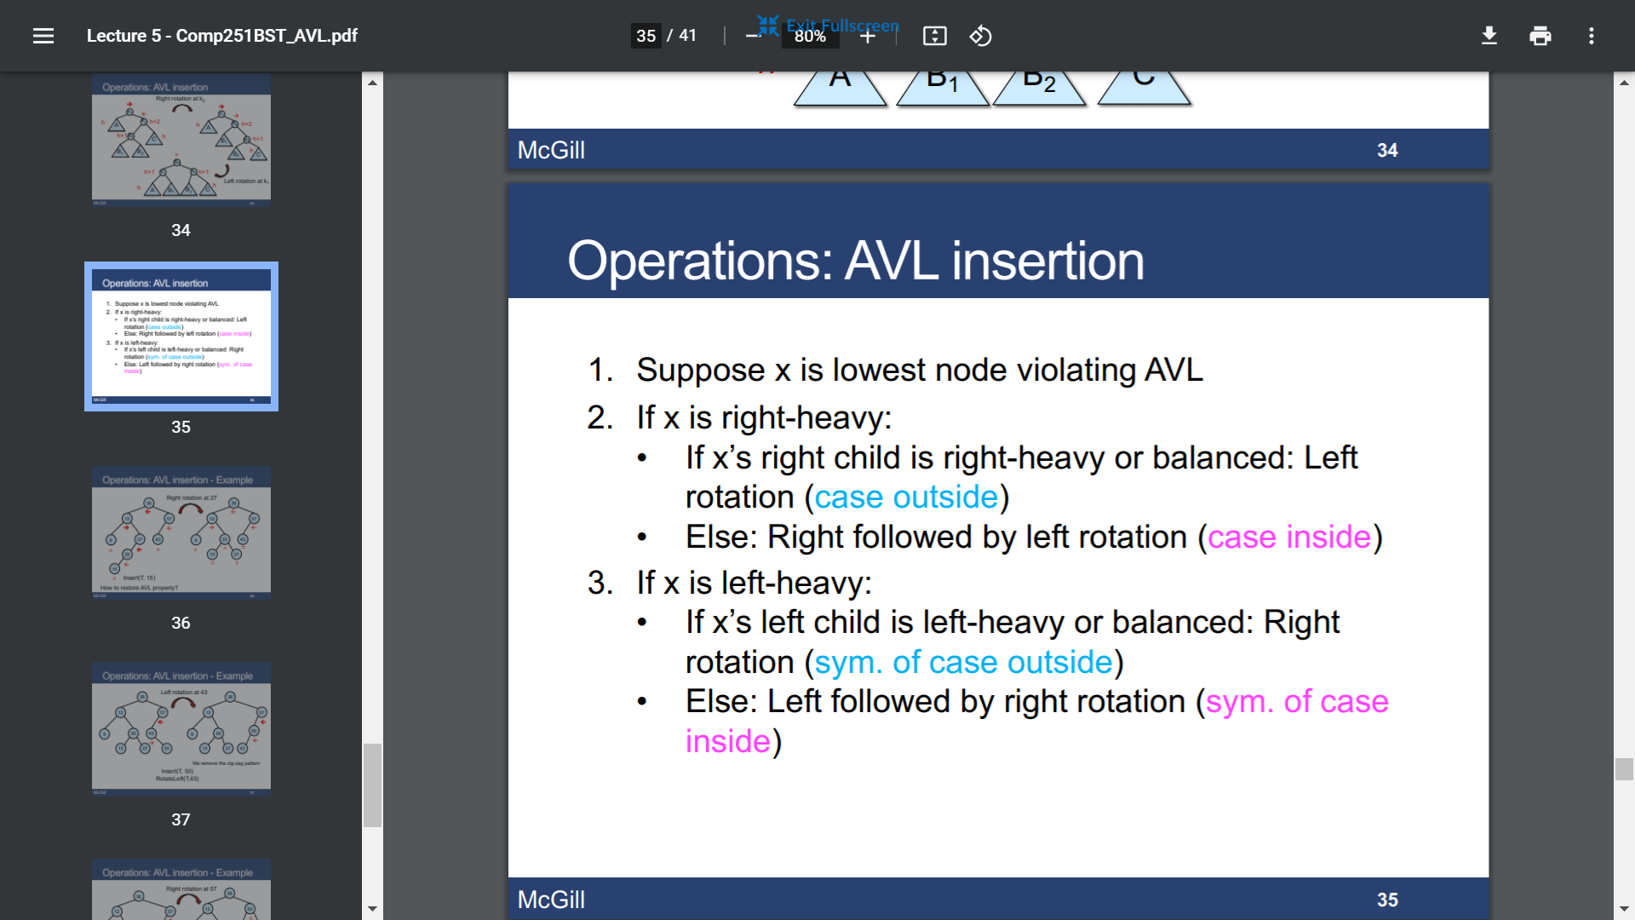

Insertion in O(h) + At most 2 rotations in O(1)

Running time: O(h) = O(lgn)

Red-Black trees

* Properties

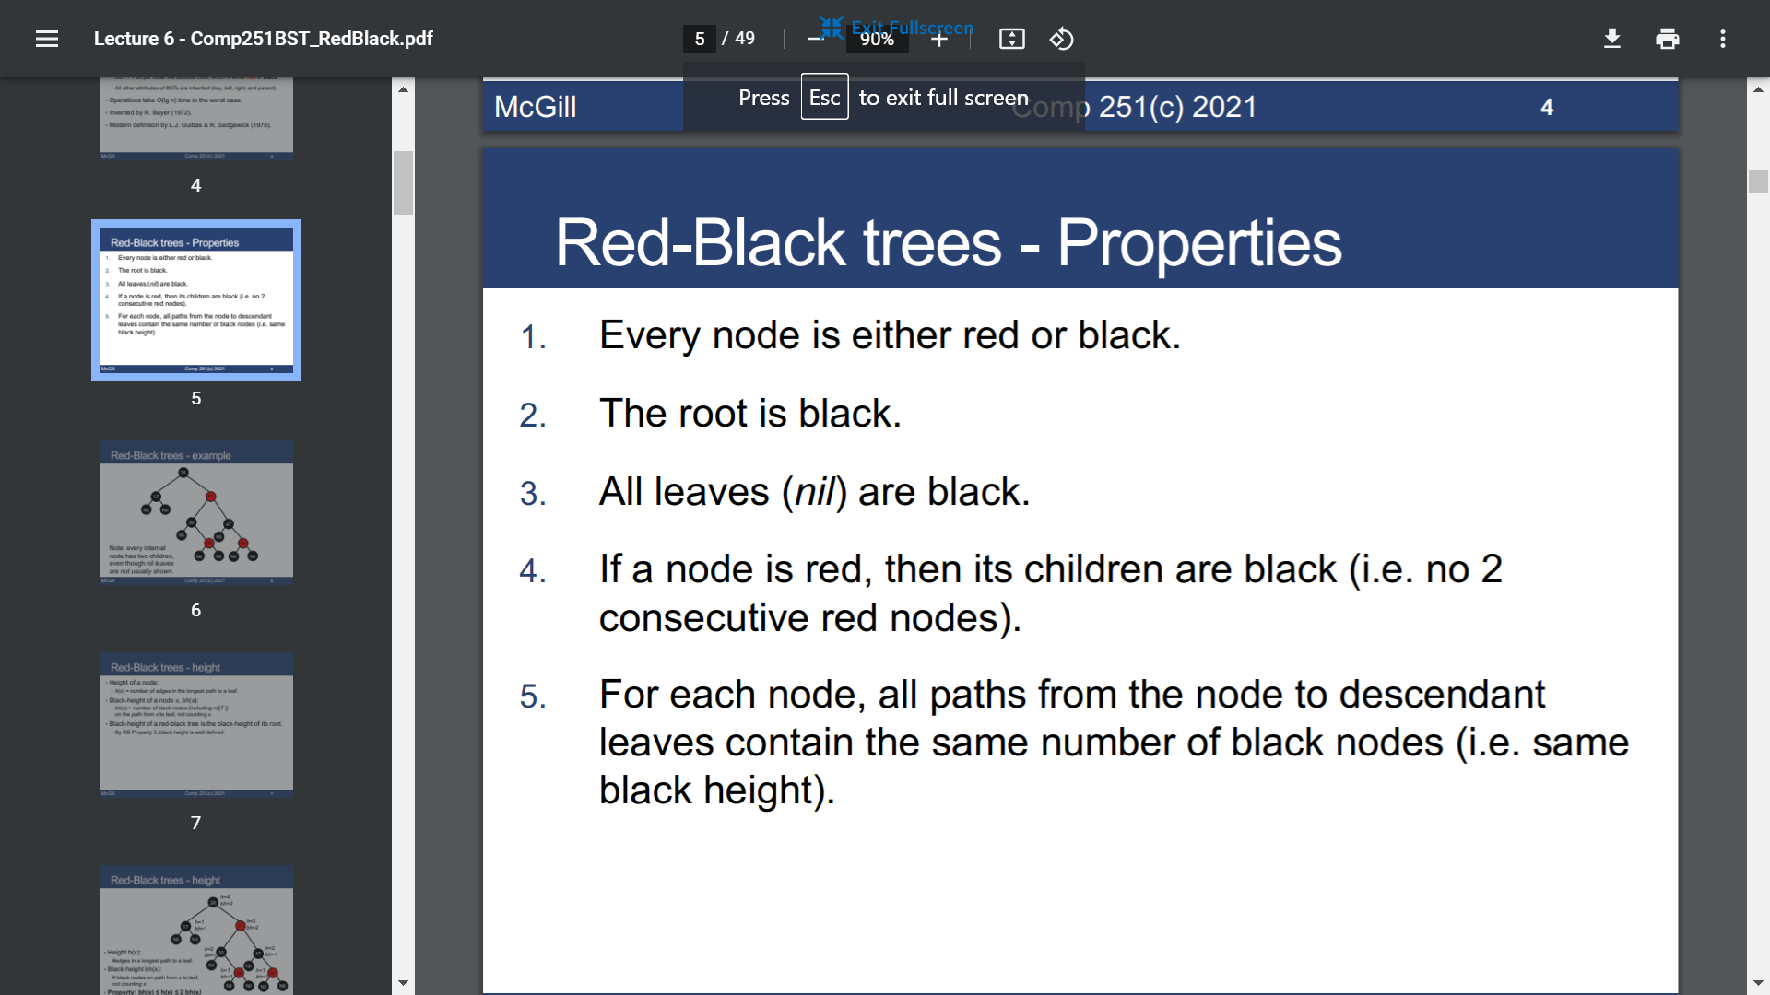

6. bh(x) <= h(x) <= 2bh(x)

7. The subtree rooted at any node x has >= 2bh(x) -1 internal nodes

8. A red-black tree with n internal nodes has height at most 2lg(n+1) 🡪 O(lgn)

* Insertion

RB-insert + RB-insert-fixup

Running time: O(lgn)

Loop repeats only when case 1 occurs and each iteration but the last moves z up 2 levels

At most 2 rotations overall

* AVL vs RB

AVL are more balanced 🡪 faster search

RB have less constrains and insert/remove operations require less rotations 🡪 faster insertion and removal

Complete search

* Recursive backtracking

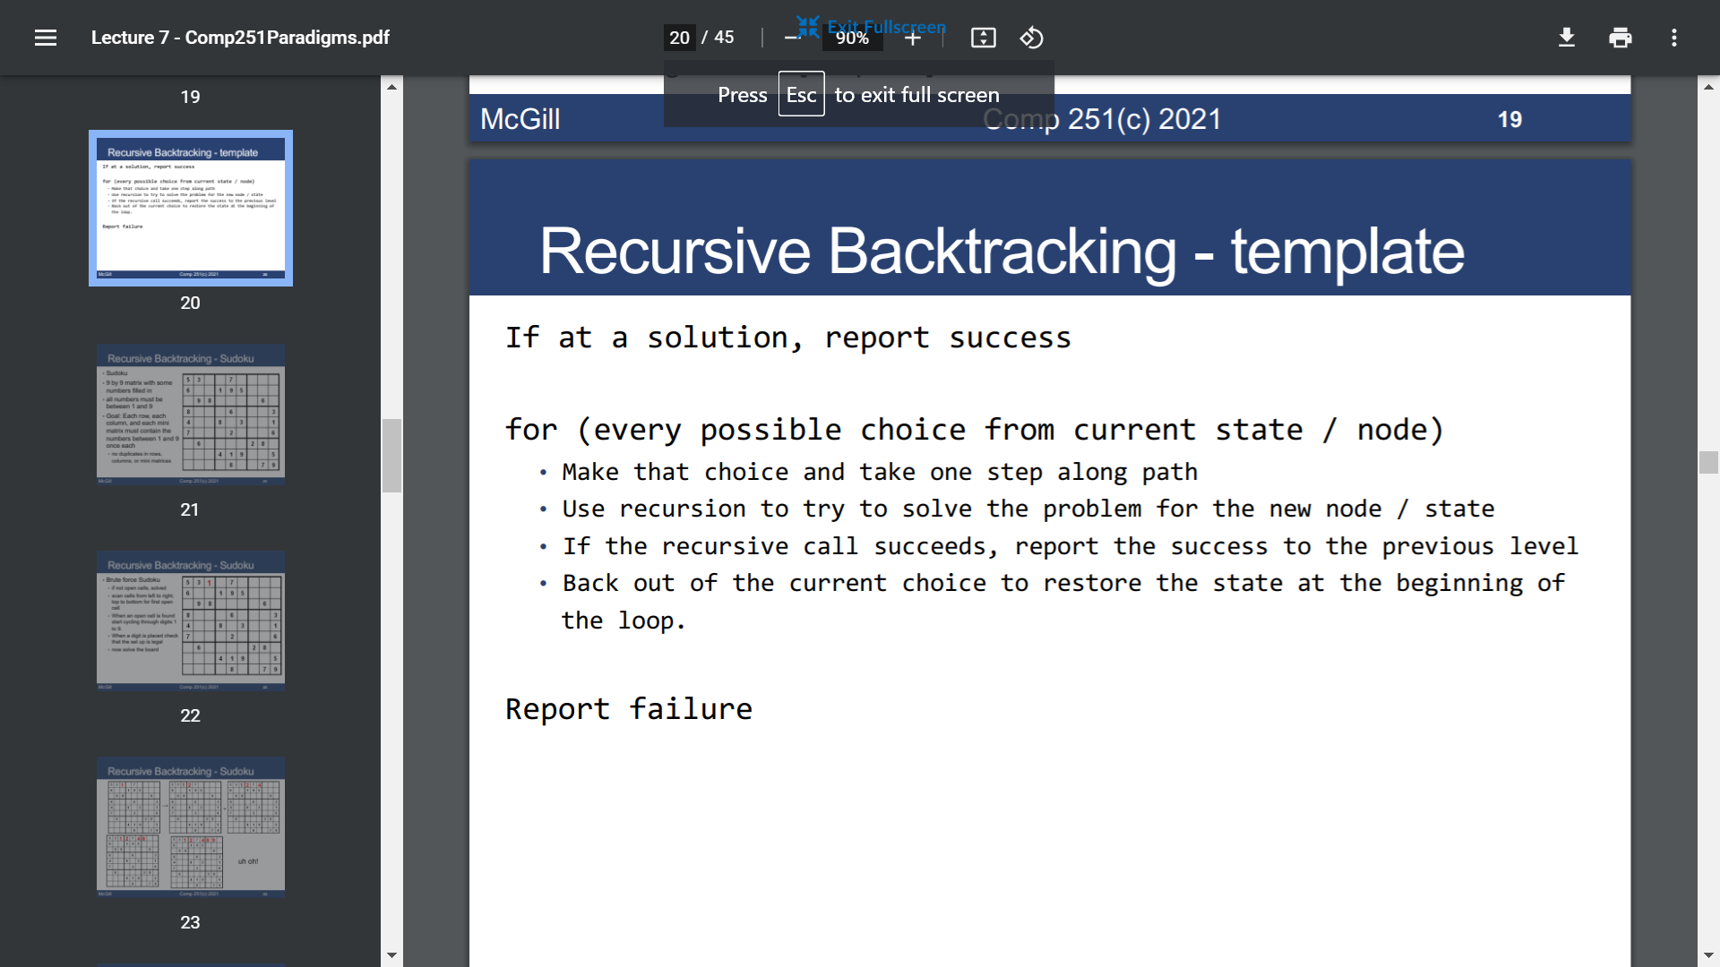

* Optimal BST

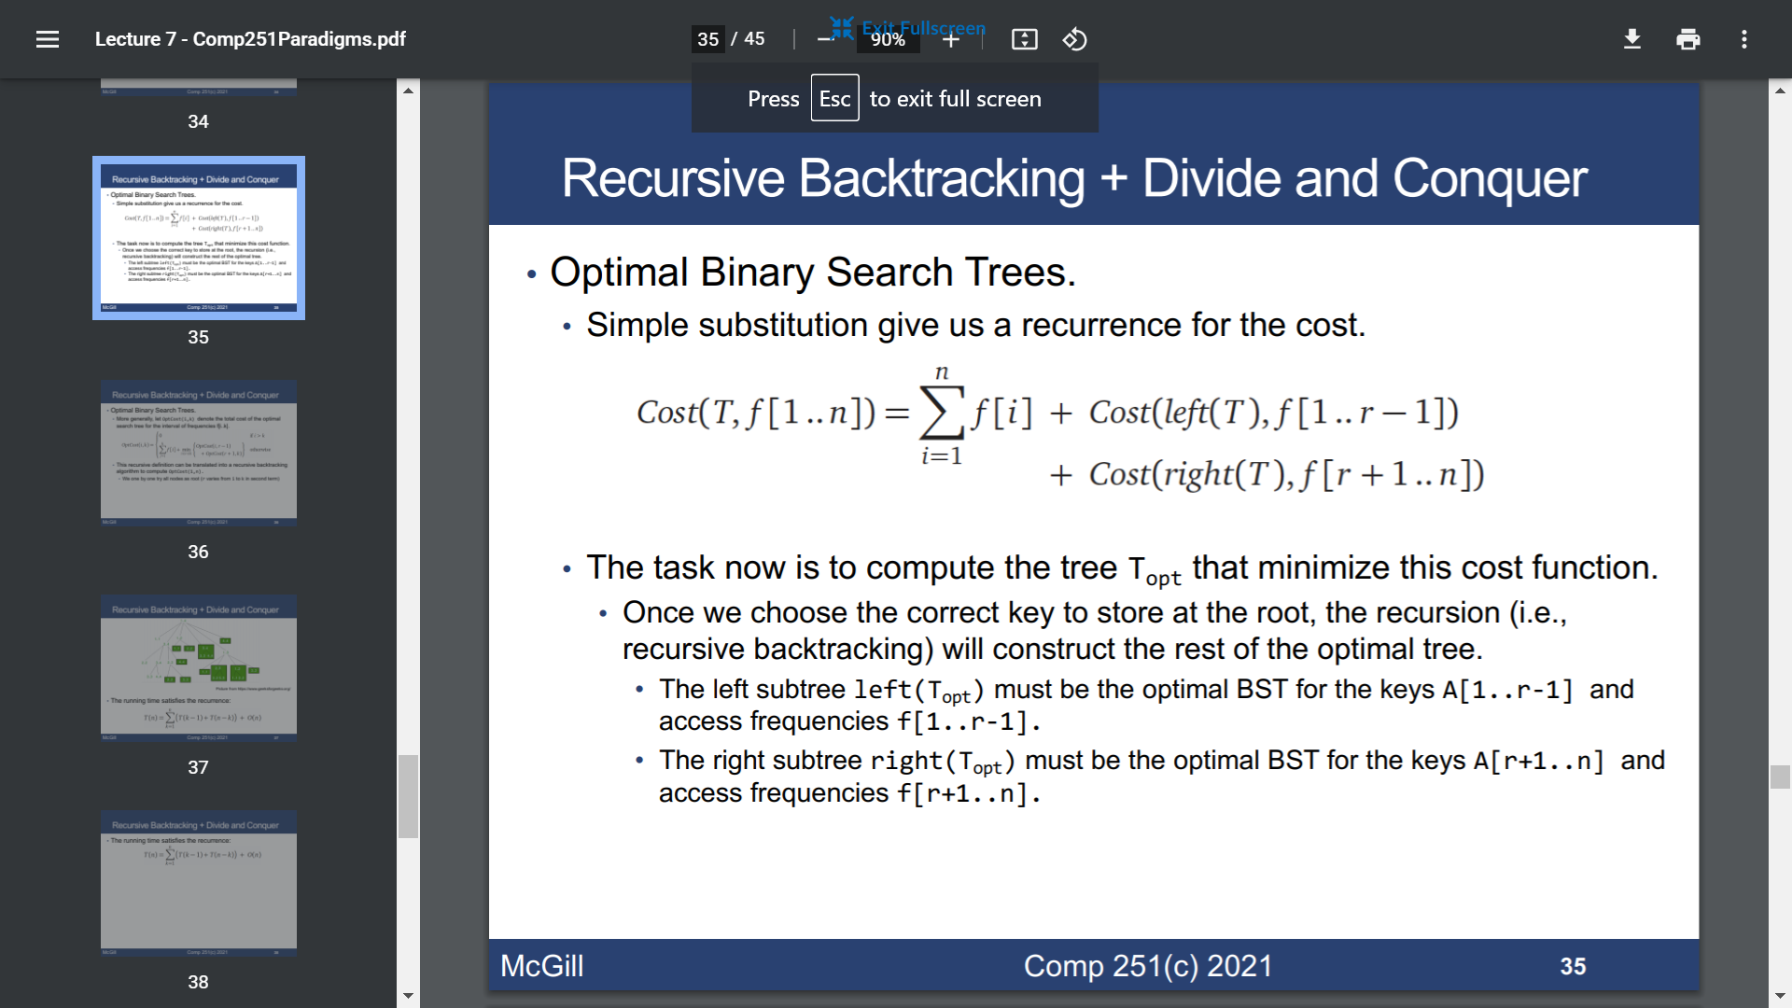

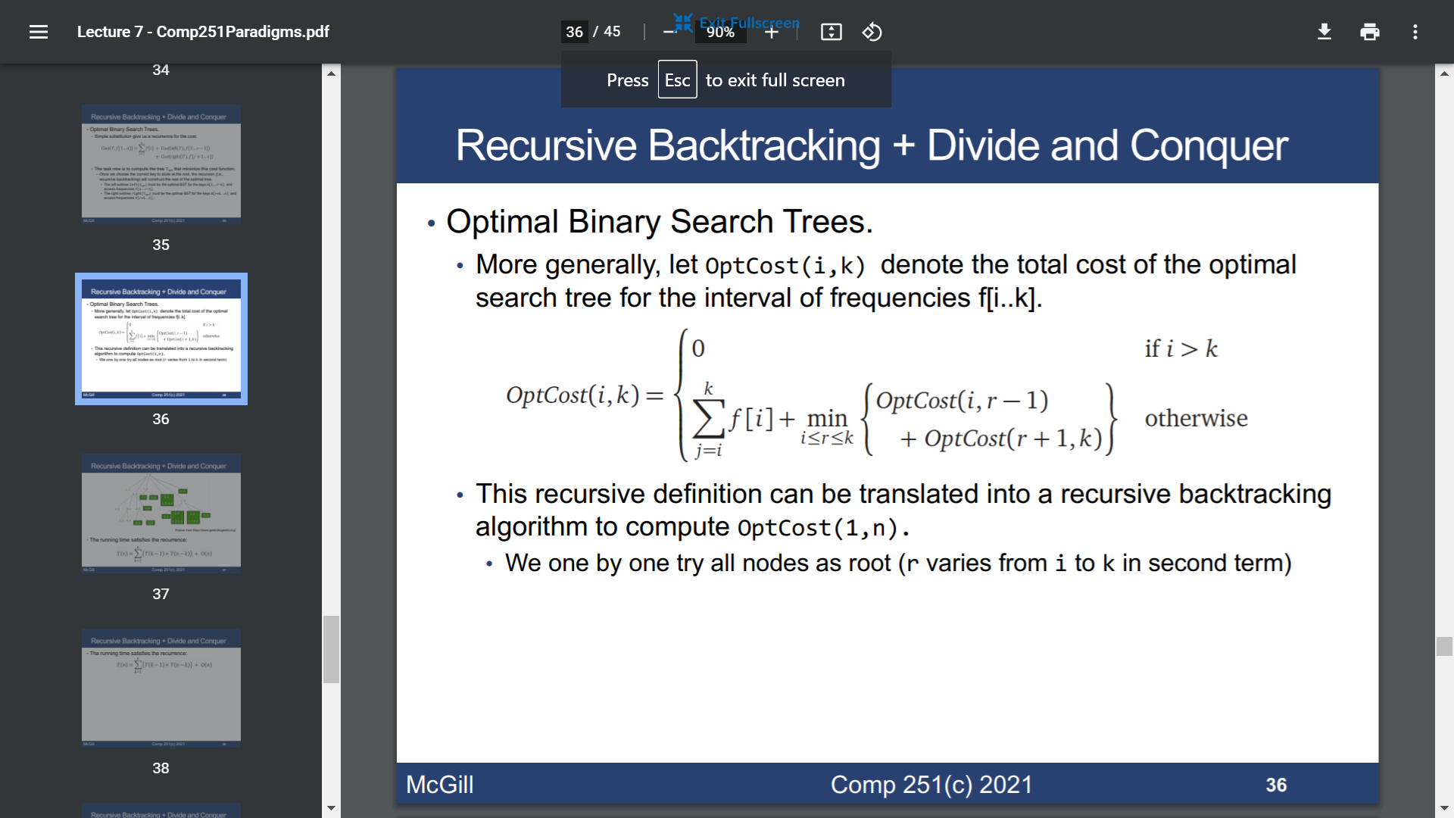

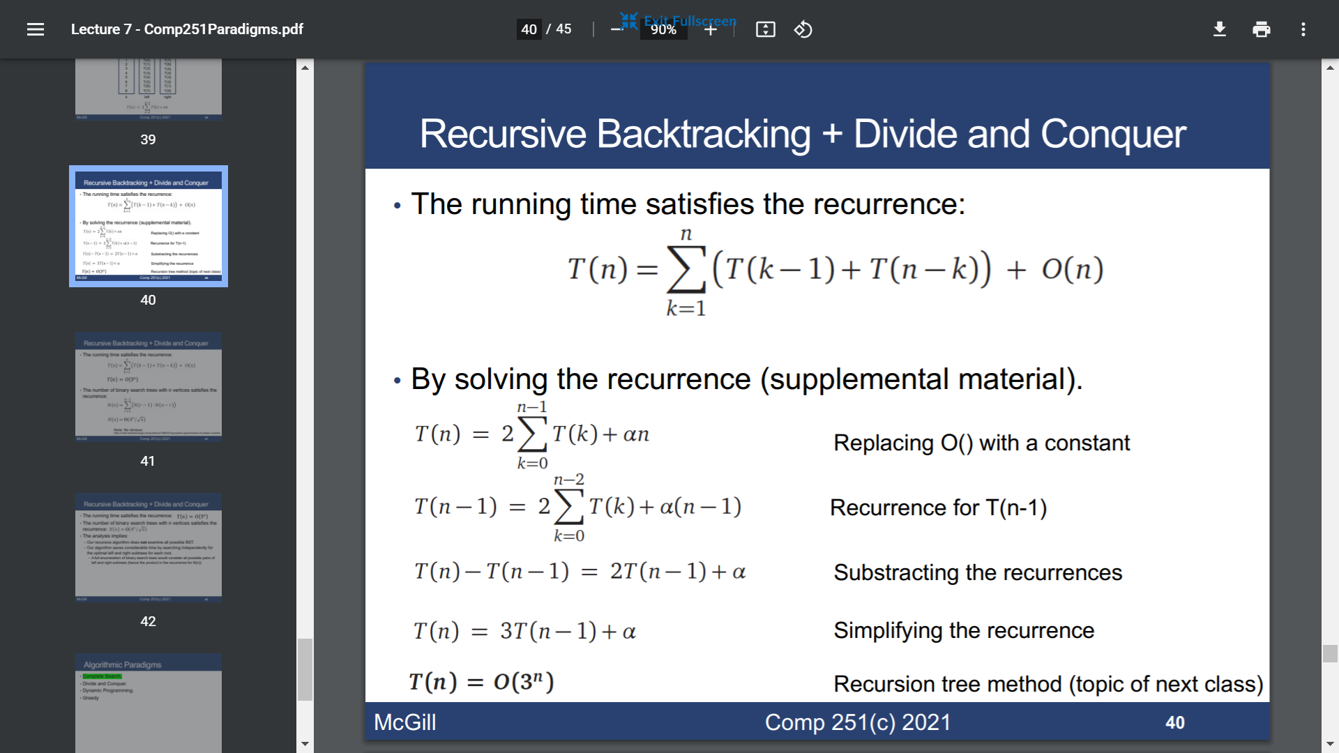

🡪 T(n) = O(3n)

Divide and Conquer

* Merge sort

T(n) = 2T(n/2) + O(n)

🡪 T(n) = O(n lgn)

* Recursion tree

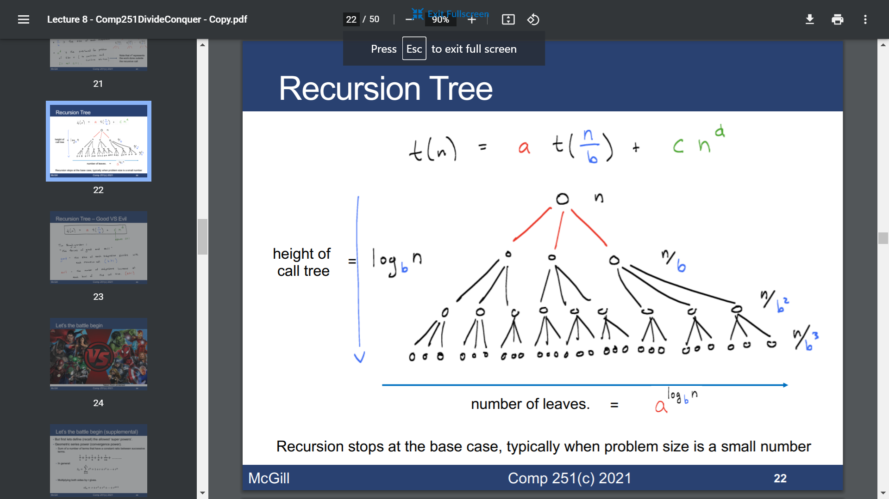

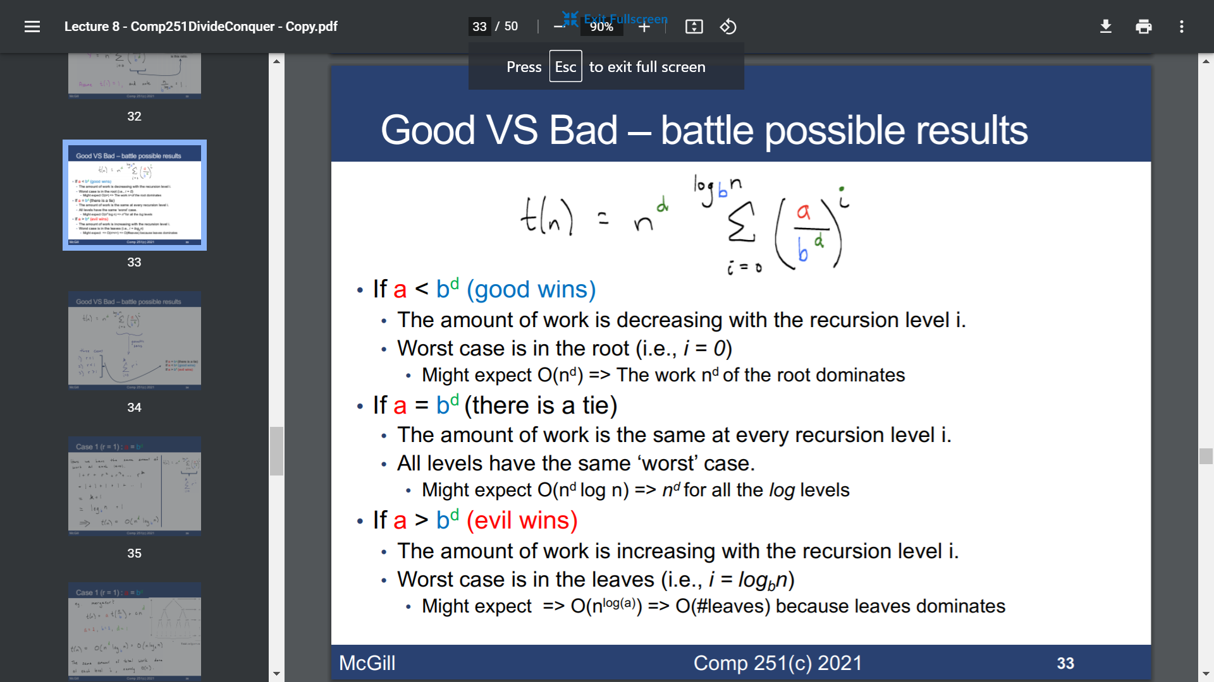

* Master theorem

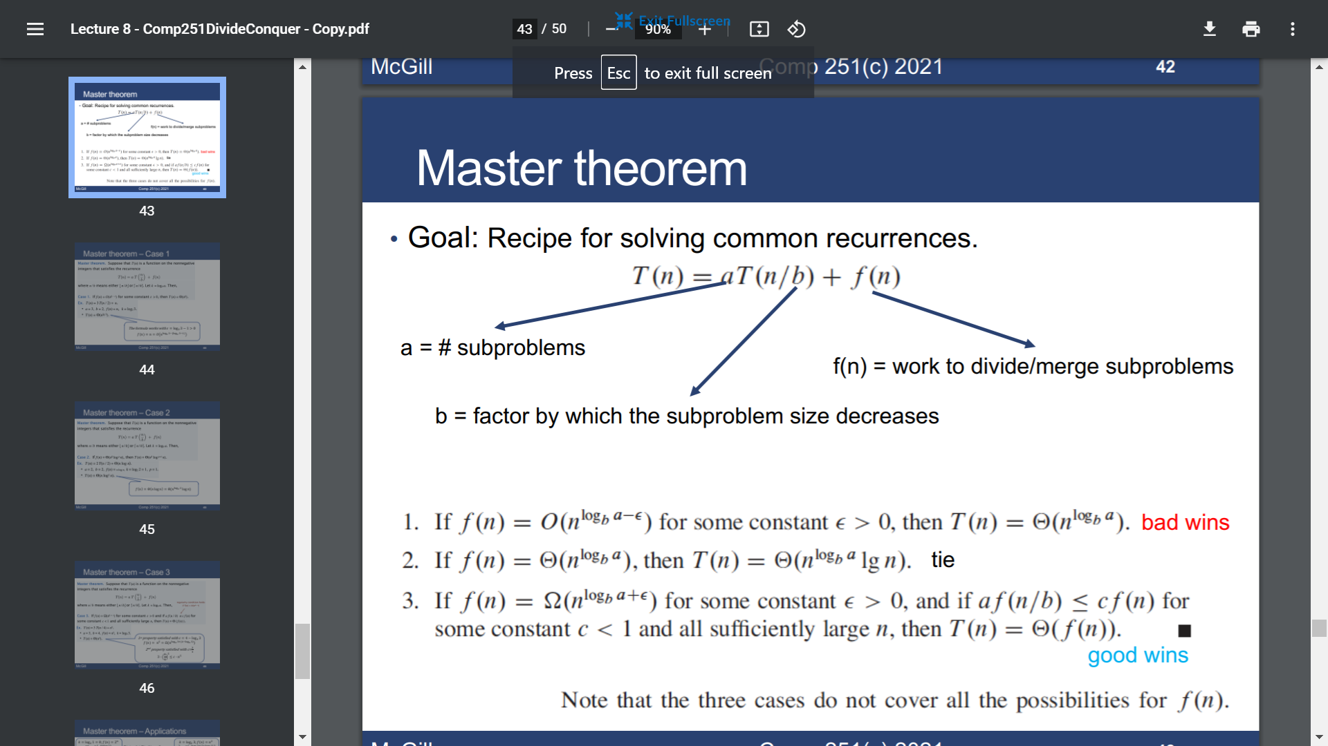

DP

Overlapping subproblems and optimal substructure

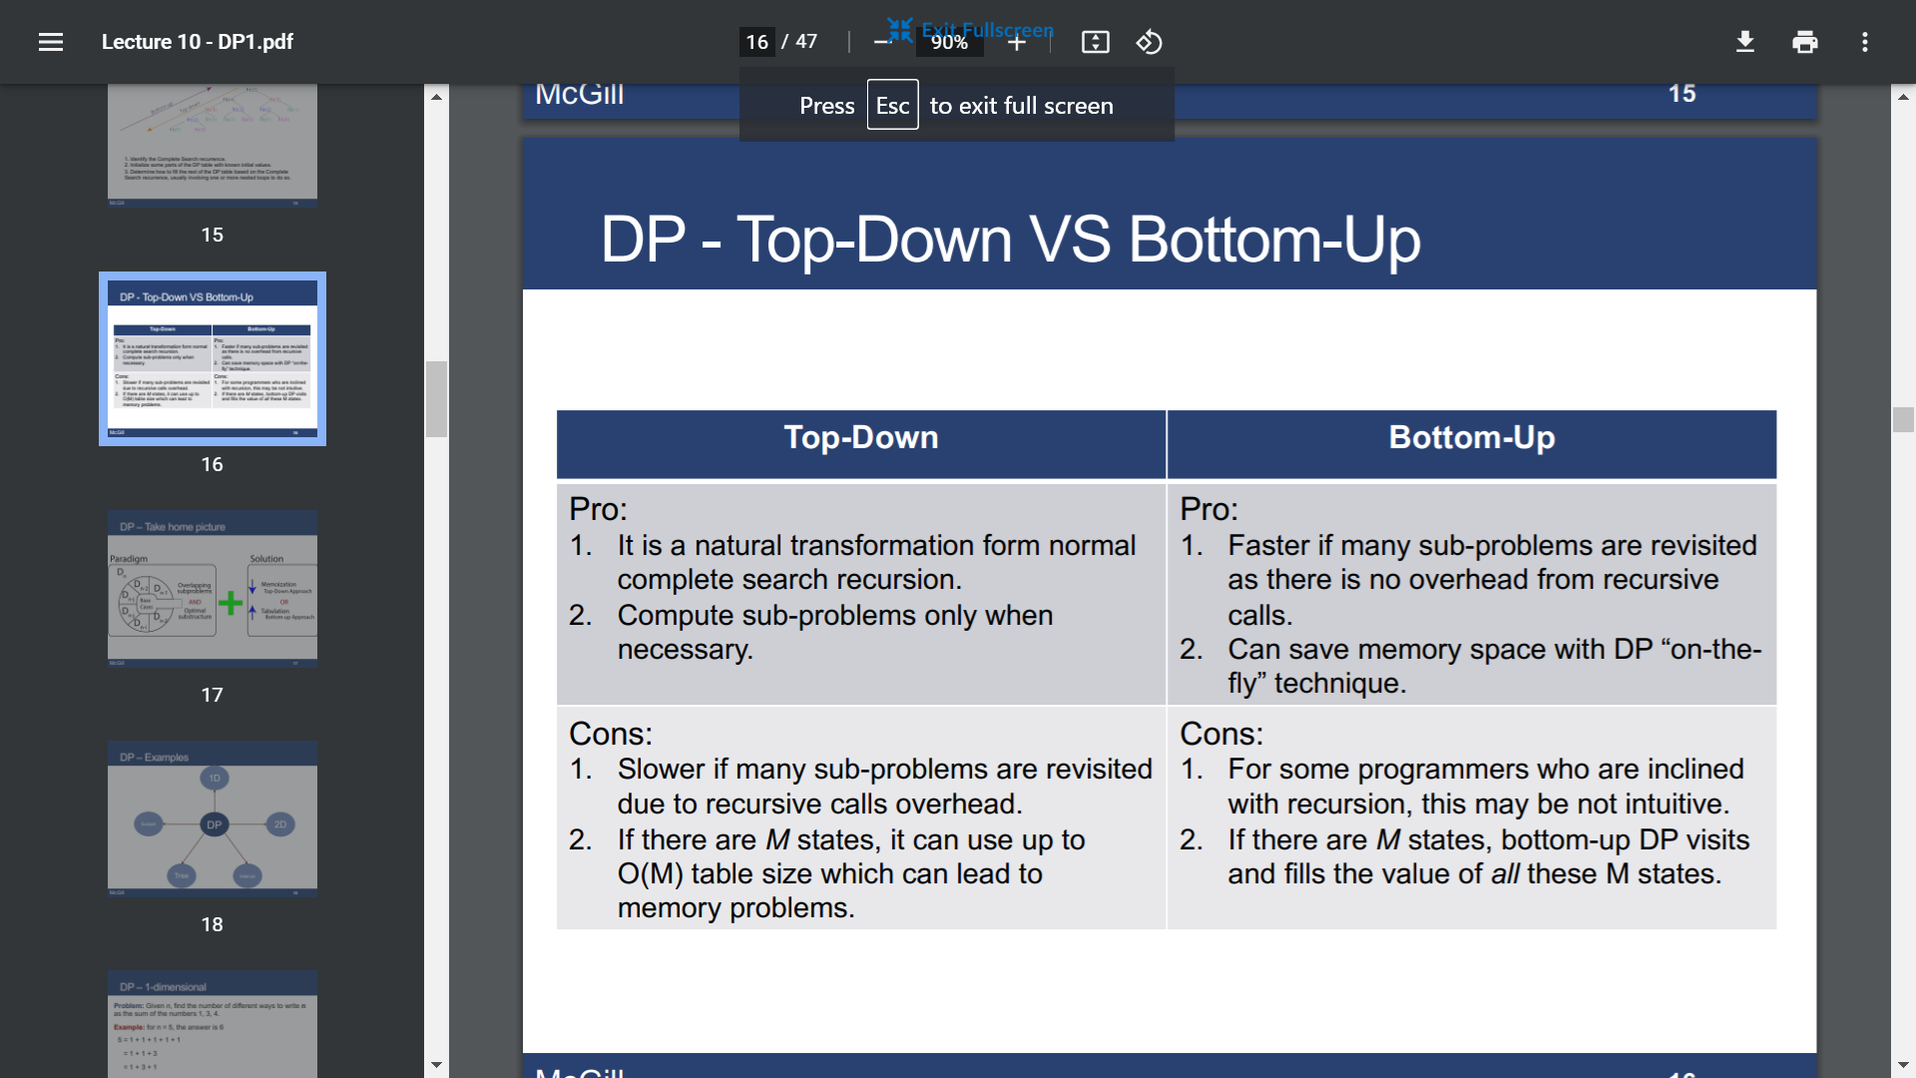

Greedy

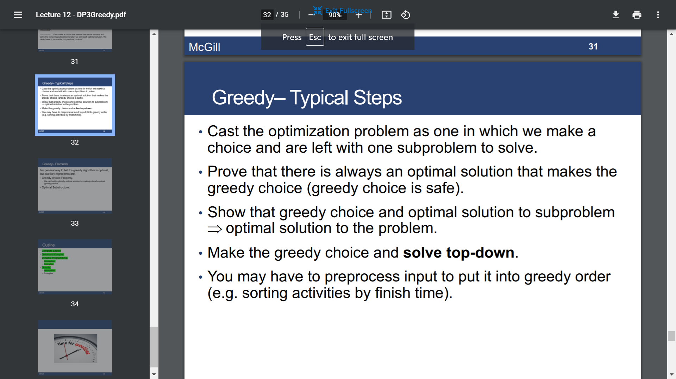

Graph

* BFS

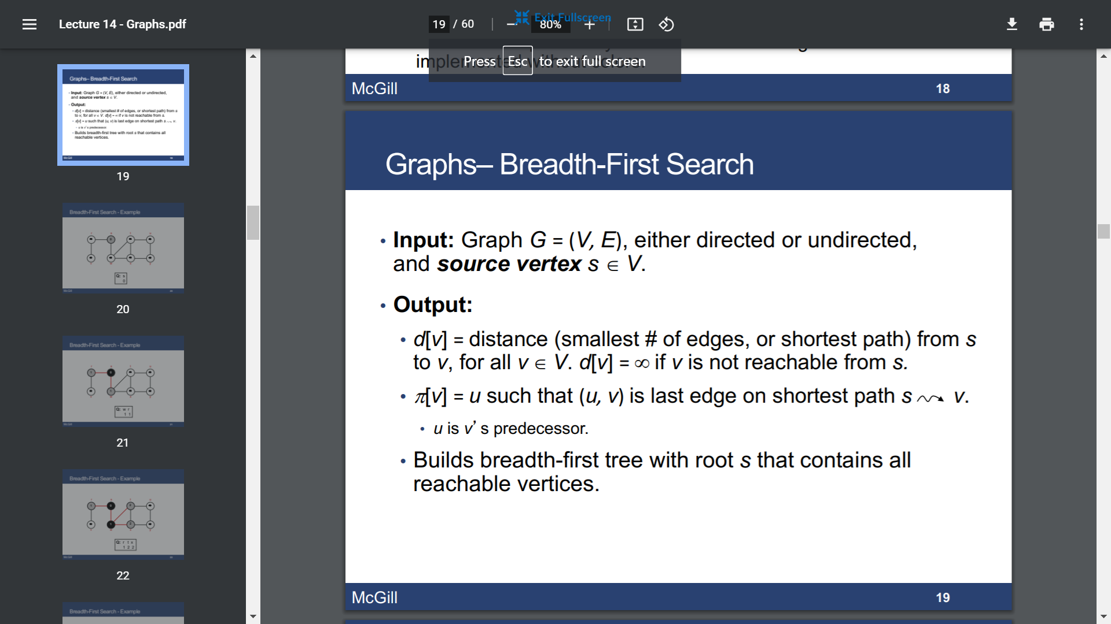

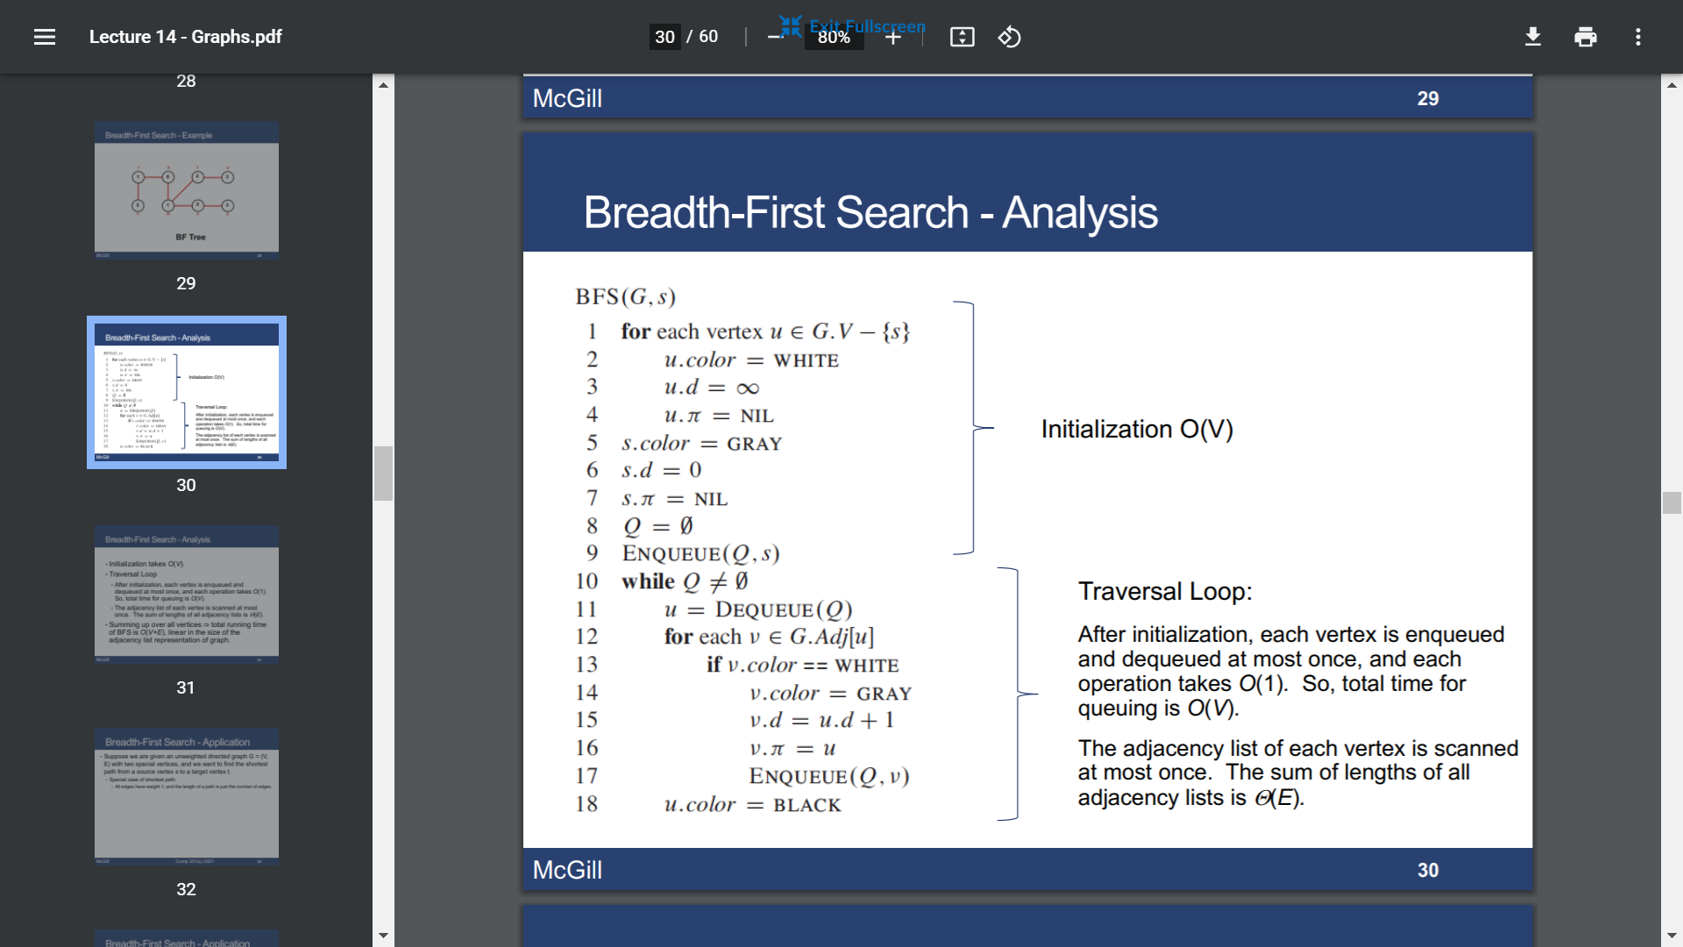

O(V+E)

Application: shortest path

* DFS

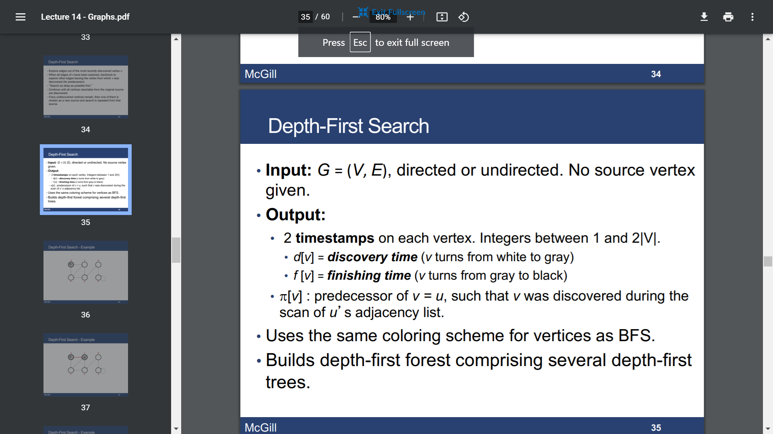

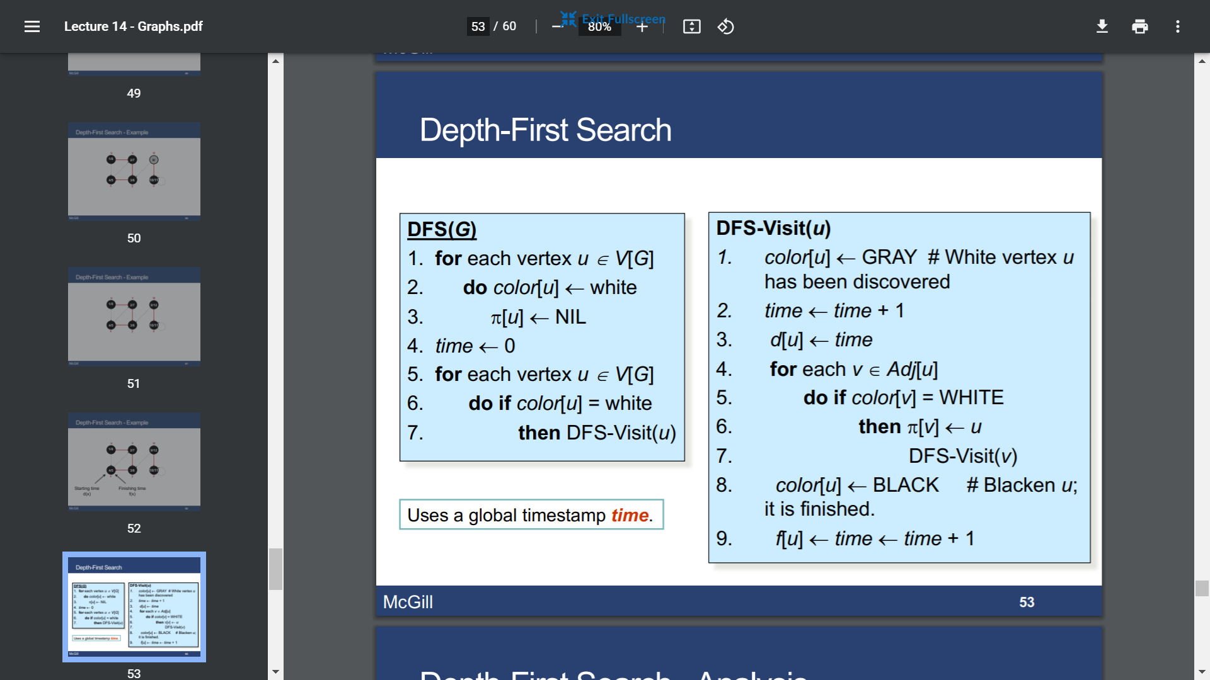

O(V+E)

Application: topological sort; parenthesis structure

* Directed Acyclic Graph

Lemma1: A directed G is acyclic iff a DFS of G yields no back edges.

* Topological sort

Linear ordering of vertices of G such that is (u,v) belongs to E then u appears somewhere before v.

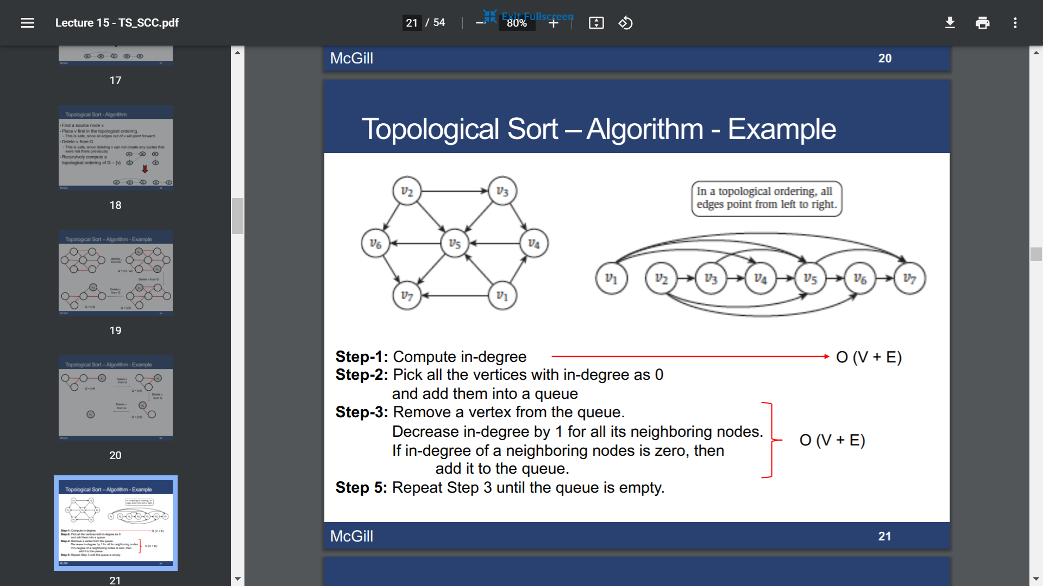

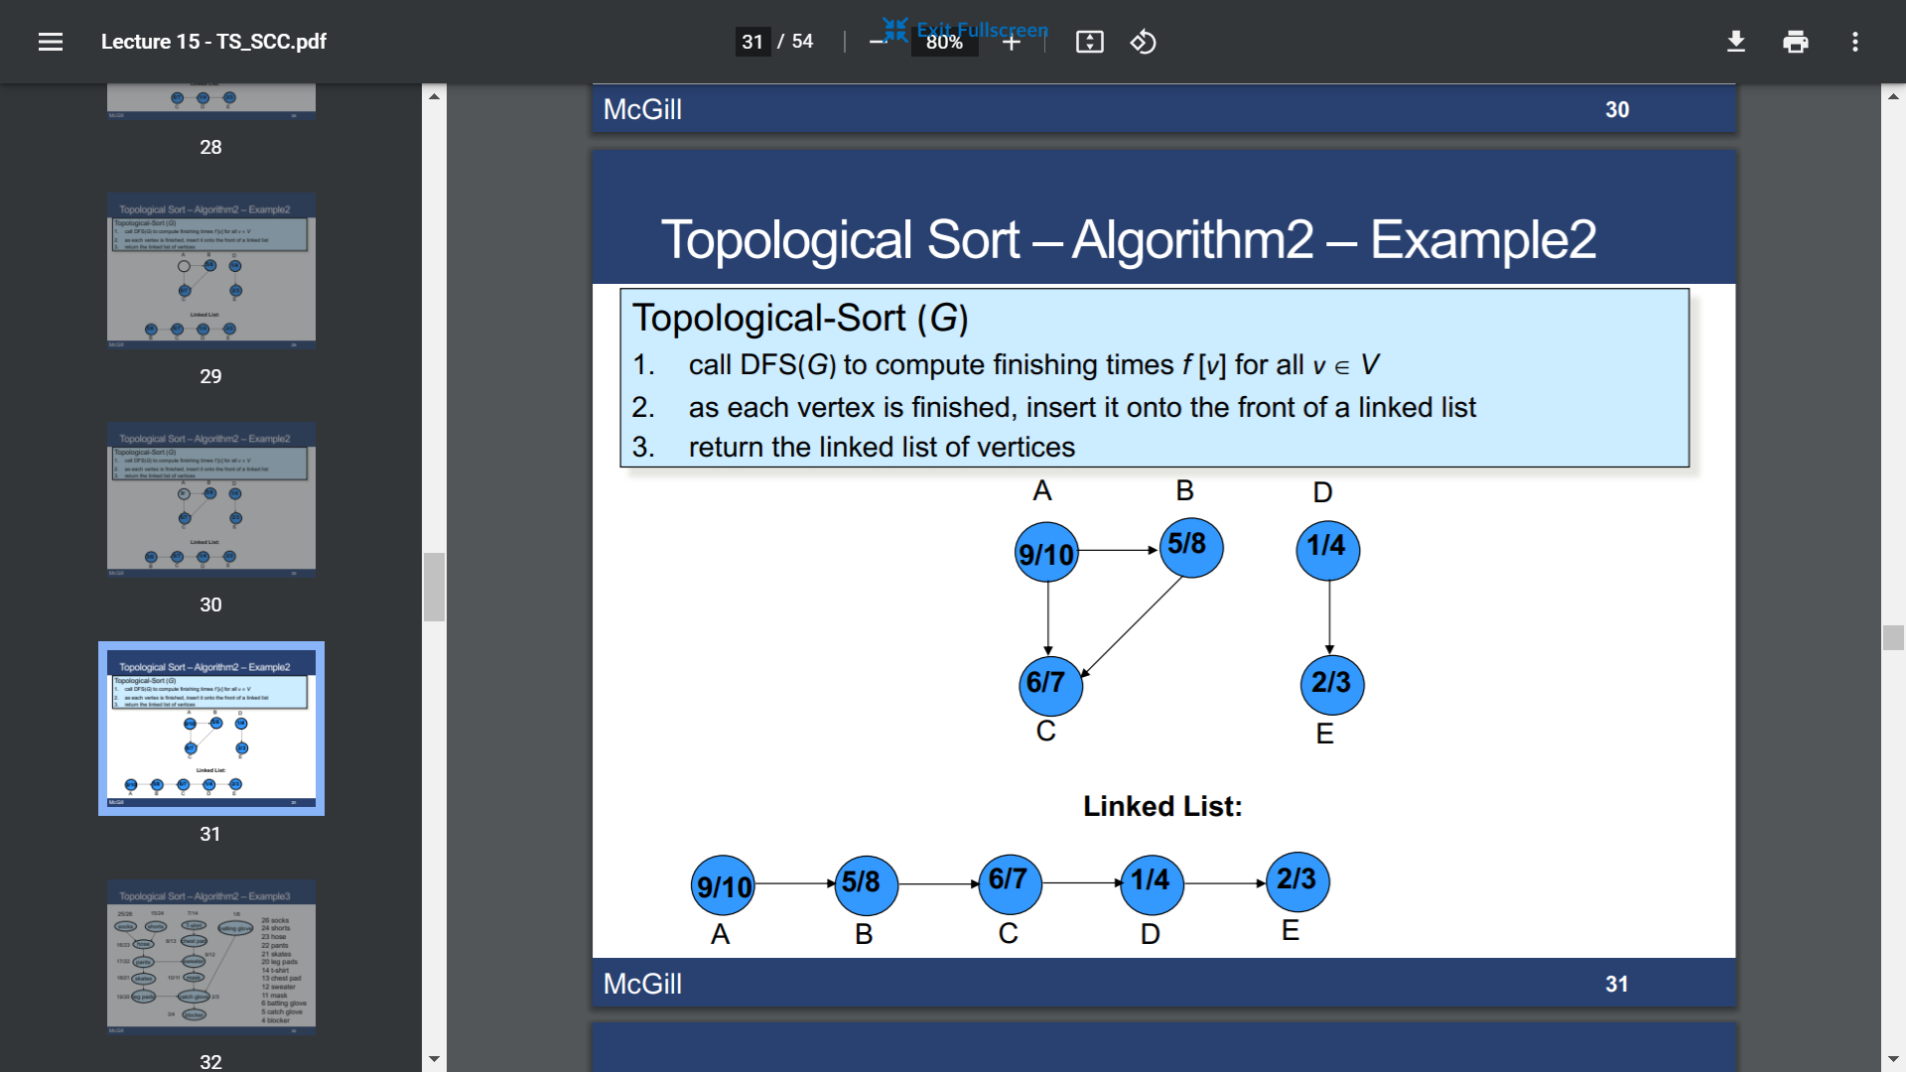

* Strongly Connected Components

Lemma2: Let C and C’ be distinct SCC in G, let u,v in C & u’,v’ in C’. Suppose there is a path u🡪u’ in G, then there cannot also be a path v’🡪v in G

Lemma3: Let C and C’ be distinct SCC in G. Suppose there is an edge (u, v) in E such that u in C and v in C’, then f (C) > f (C’)

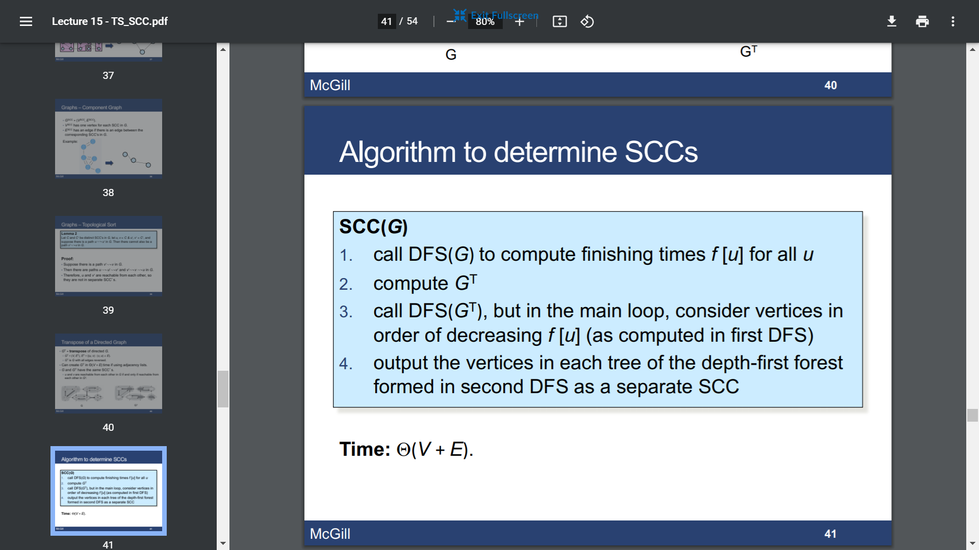

Correctness:

1. At the beginning, DFS visit only vertices in the first SCC
2. DFS doesn’t visit more than one new SCC at the time

Flow Network

* Introduction

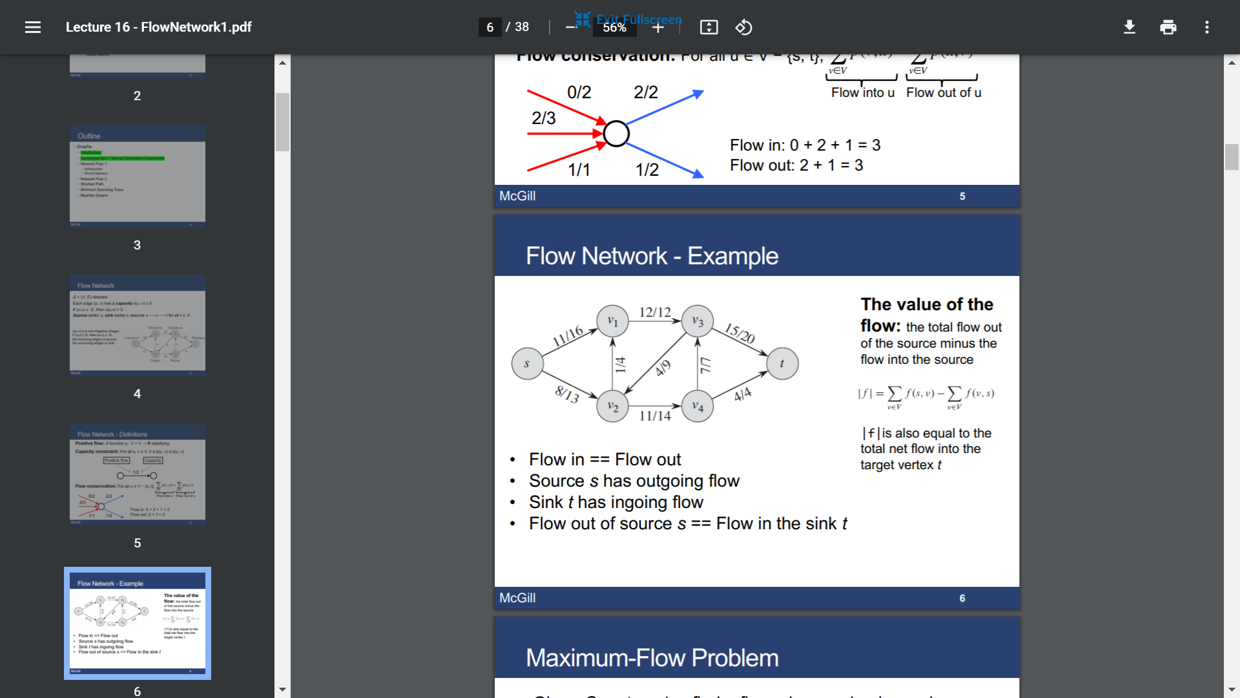

* Maximum flow

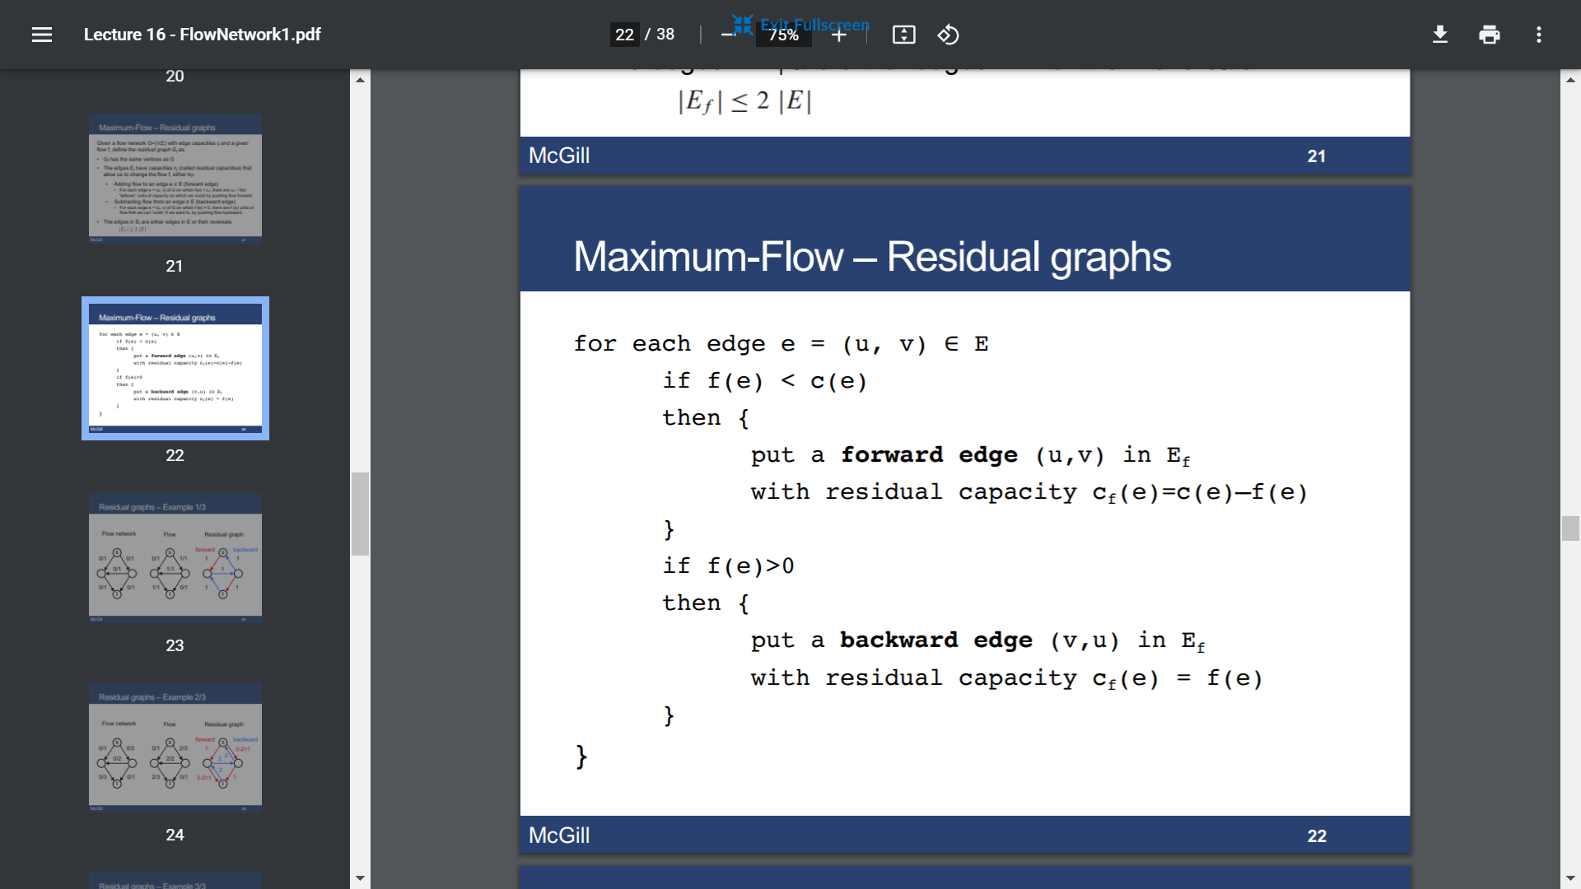

Augmenting path: a path from source to sink in the residual graph that allows us to increase the flow.

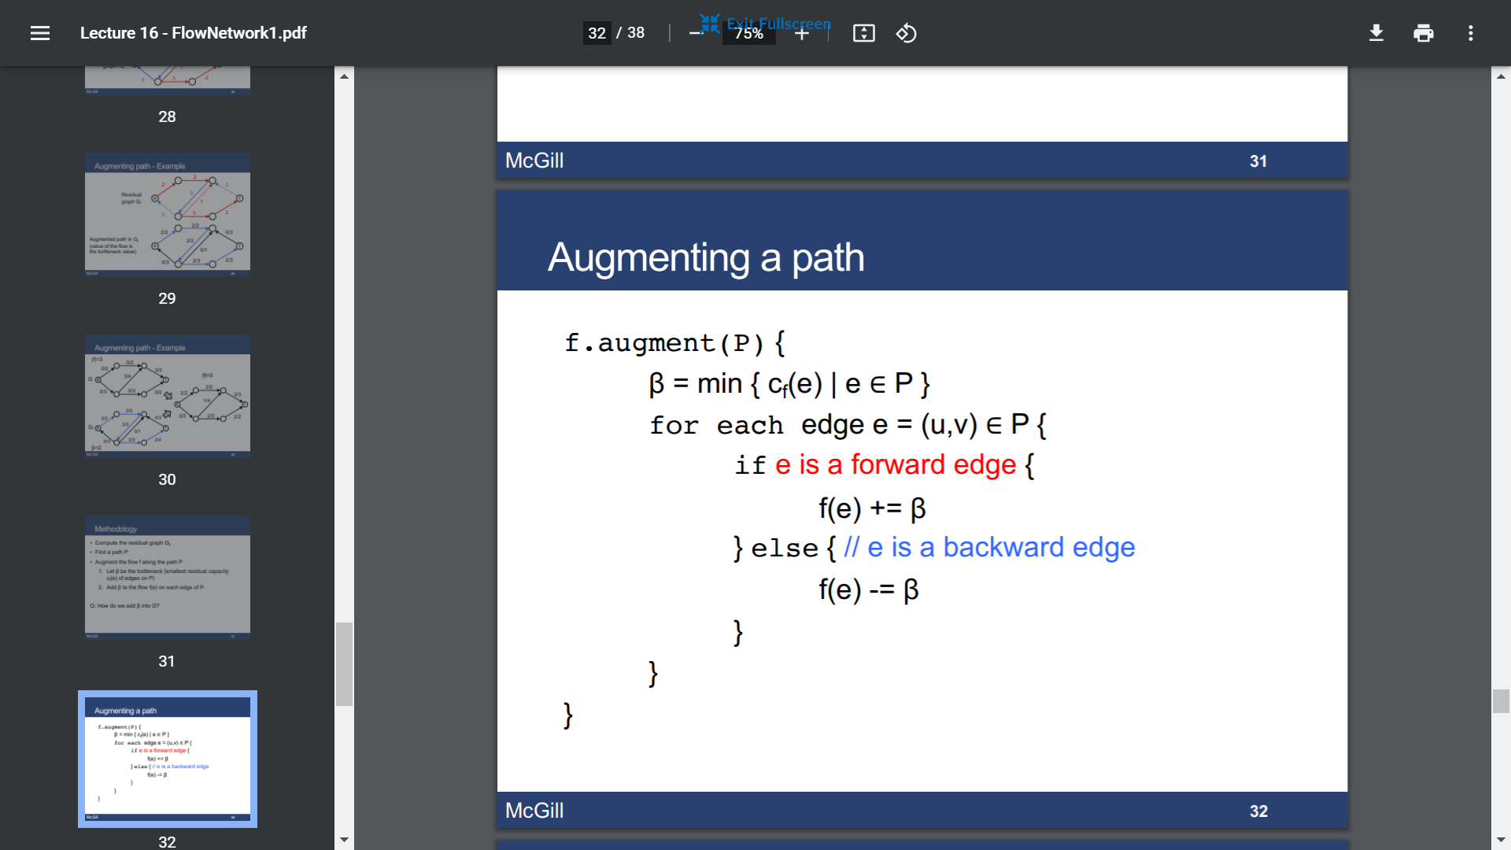

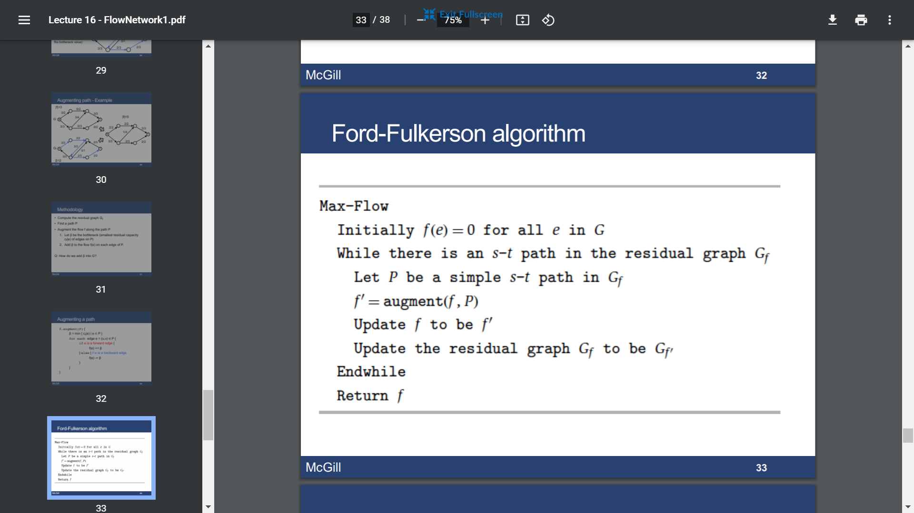

O(C\*E), C=max flow

* Min cut

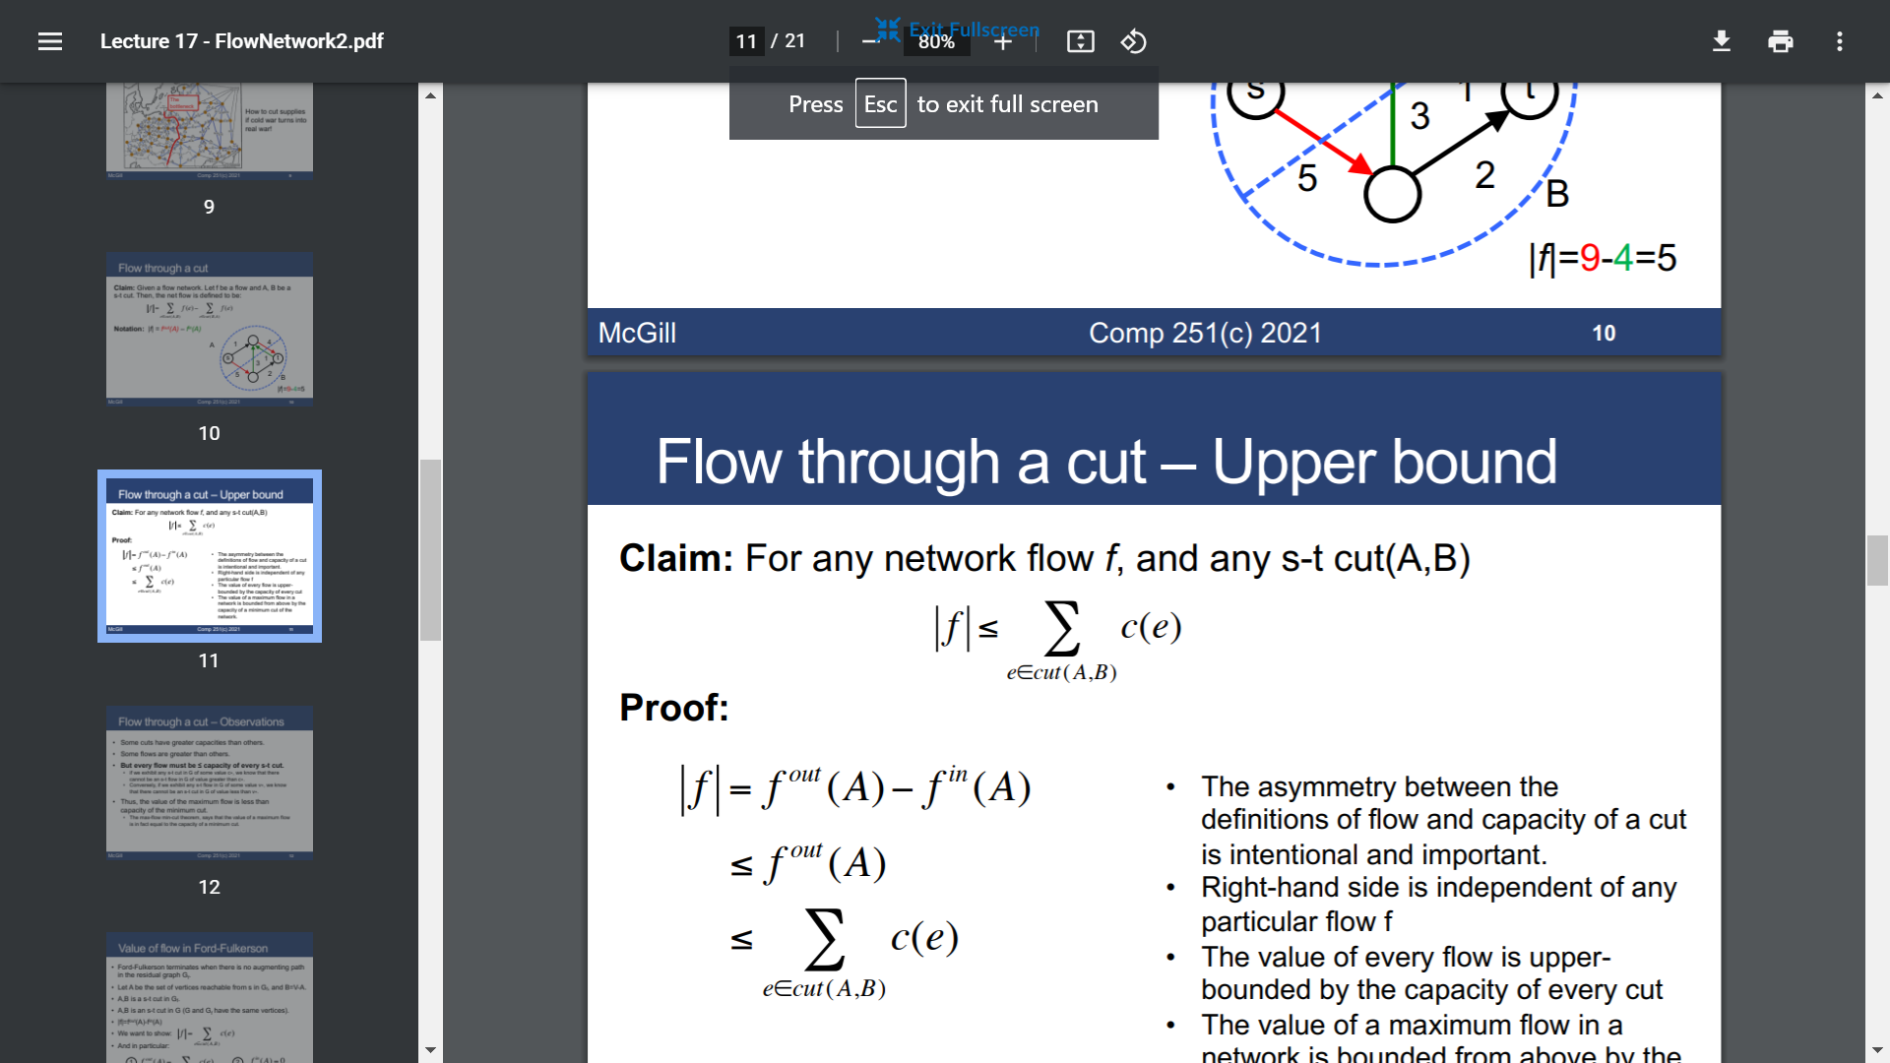

Thus max flow <= capacity of min cut

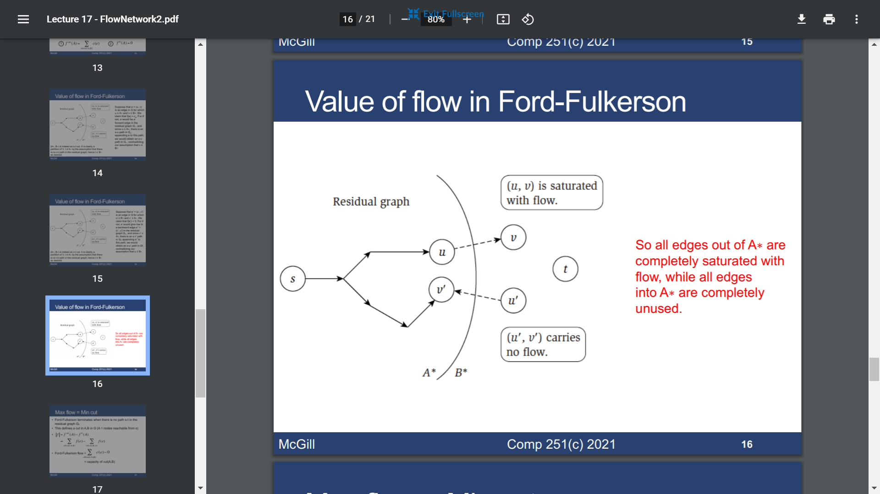

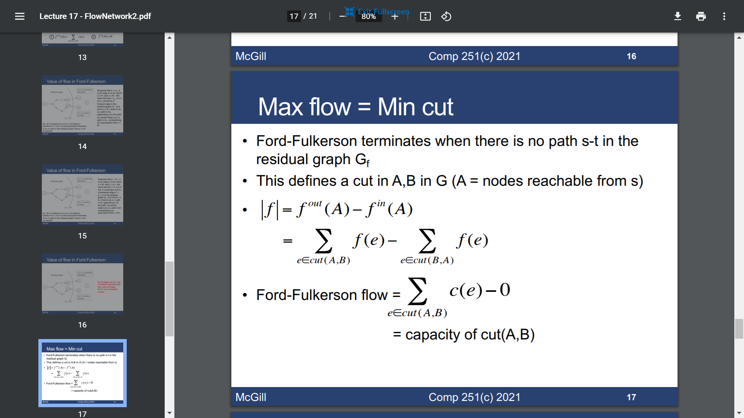



Shortest Path (SSSP)

* Relaxation

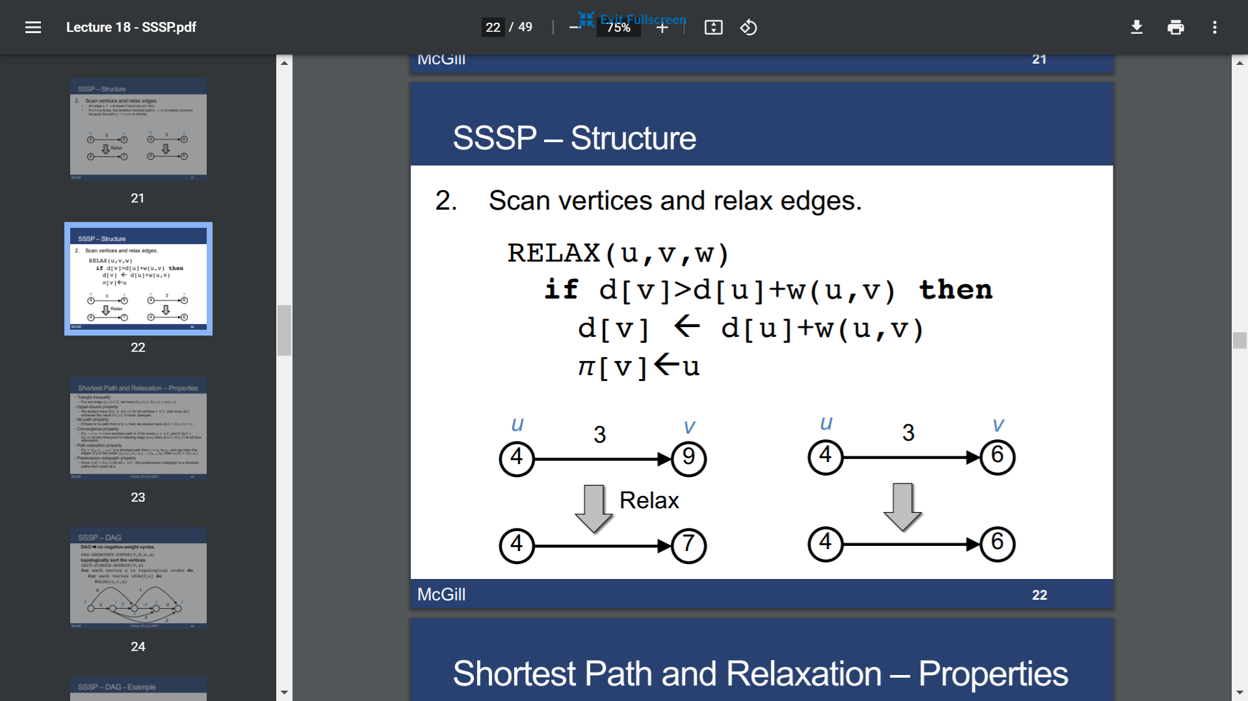

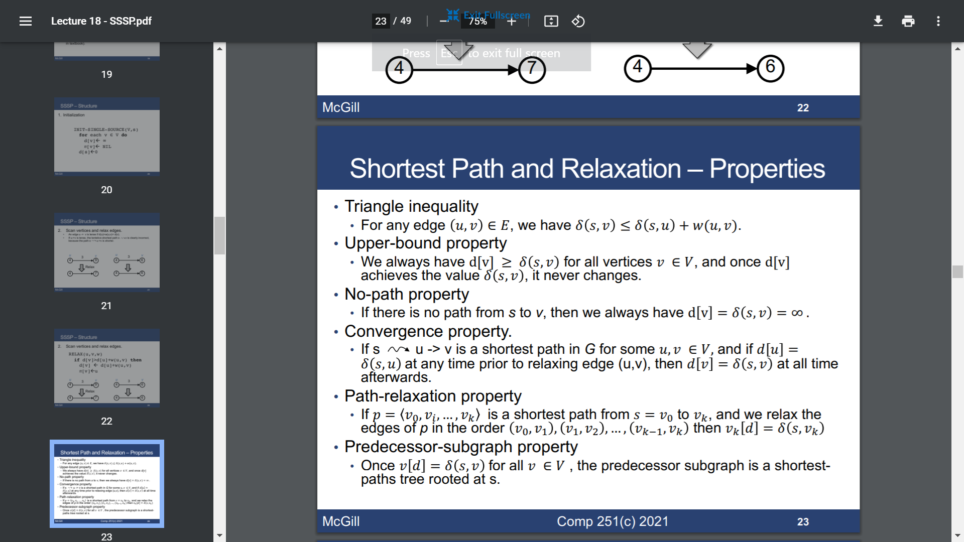

* DAG

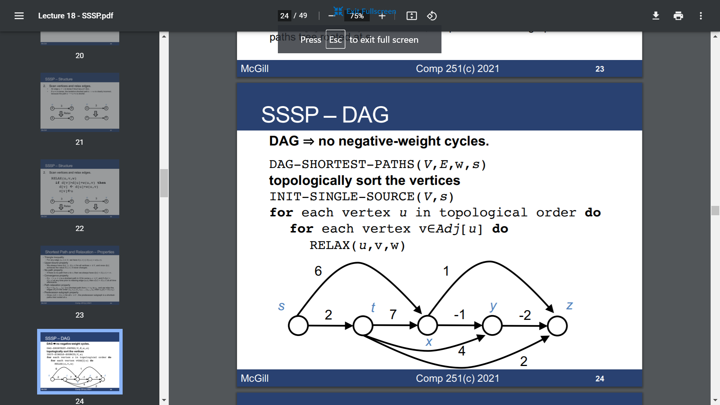

O(V+E)

* Dijktra’s algorithm

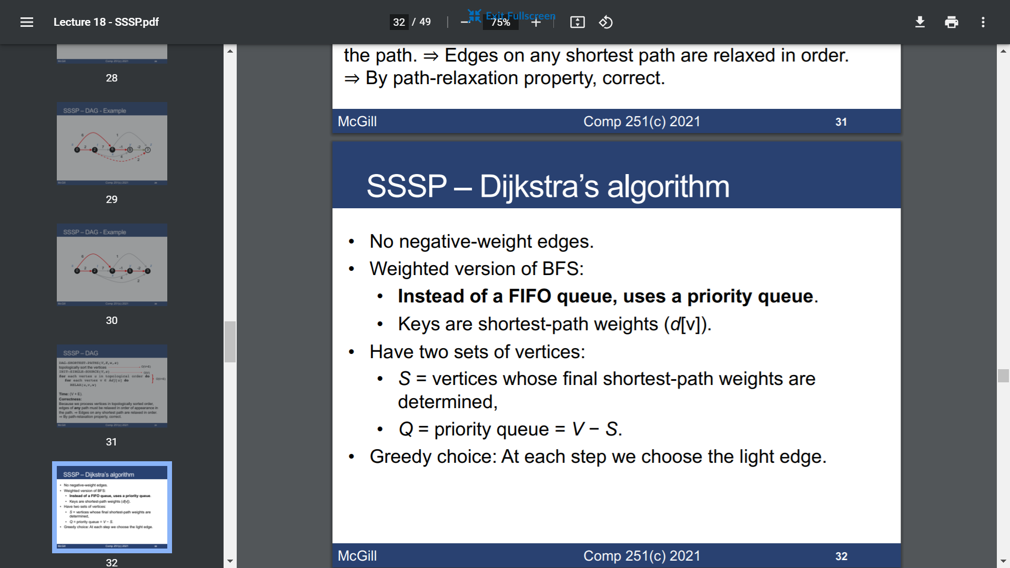

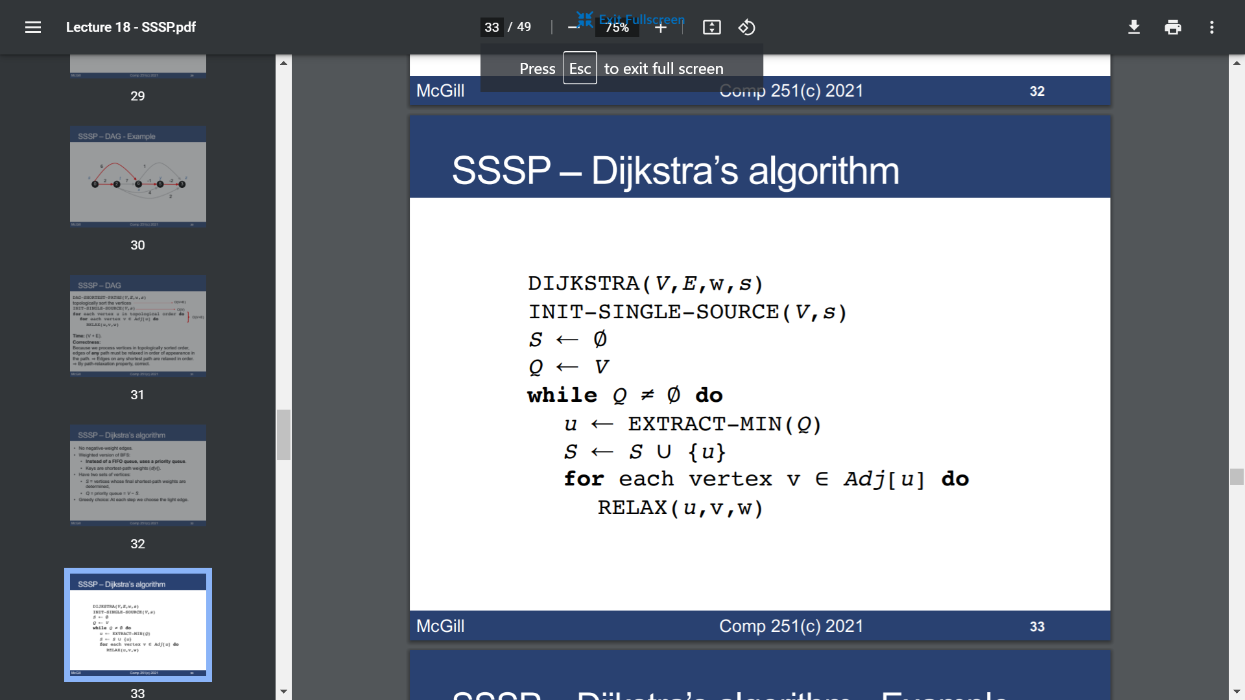

O(E+V lgV)

Minimum Spanning Tree

* Safe edge

Thm1: Let (S, V-S) be any cut that respects A, and let (u, v) be a light edge crossing (S, V-S). Then

(u, v) is safe for A.

Corollary: If (u, v) is a light edge connecting one CC in (V, A) to another CC in (V, A), then (u, v) is safe for A.

* Kruskal’s algorithm

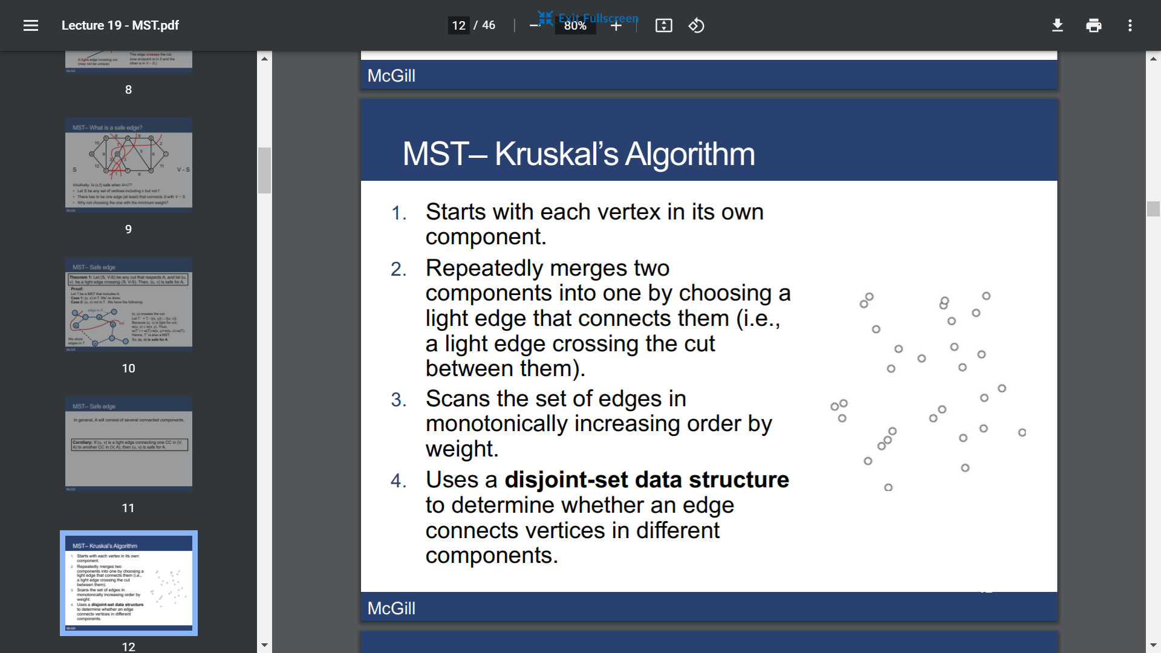

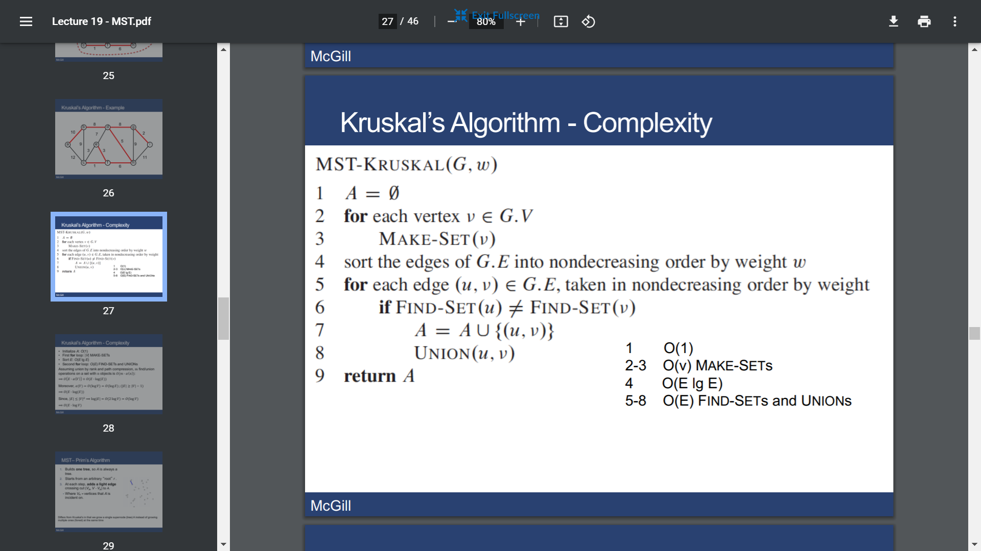

O(E lgV)

* Prim’s algorithm

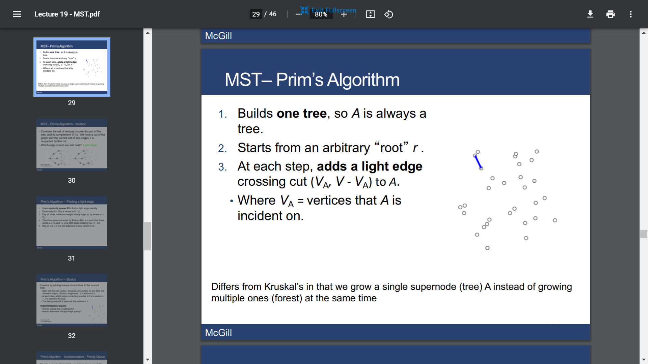

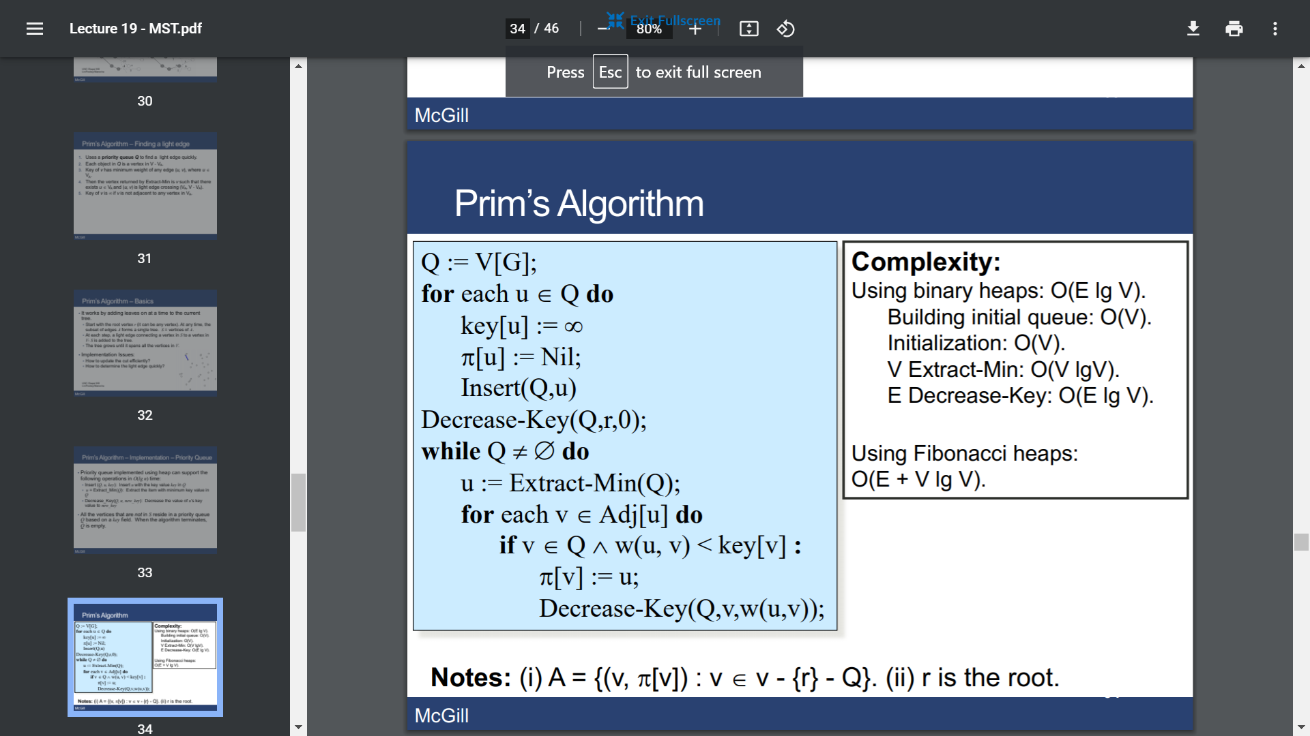

Bipartite Graphs

* Stable perfect matching

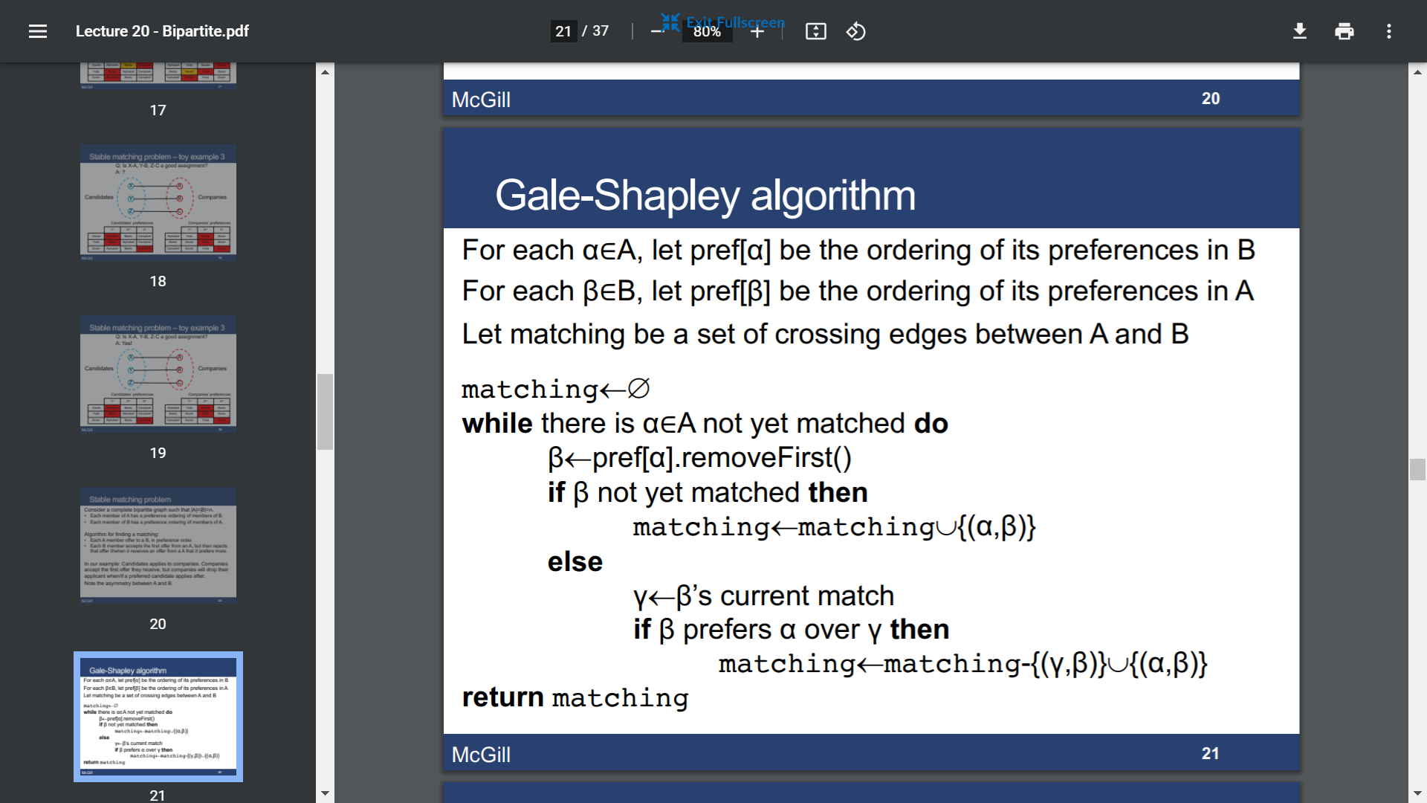

This is a A-optimal matching.